**Yoga Pose Classification, Analysis and Feedback Generation Using Deep Learning**



**Kalyani Government Engineering College**

(Kalyani, Nadia, West Bengal, India. Pin-741235)

Affiliated to

**Maulana Abul Kalam Azad University of Technology**

Under the guidance of

**Dr. Partha Garai**

Assistant Professor, Dept. of Computer Application, KGEC

Submitted By

| **Alok Sarkar** | **(10201019009)** |
| --- | --- |
| **Subrata Halder** | **(10201019005)** |

**Kalyani Government Engineering College**



**CERTIFICATE**

This is to certify that the project report on “Yoga Pose Classification, Analysis and Feedback Generation Using Deep Learning” is a record of project work under the curriculum of Maulana Abul Kalam Azad University of Technology(MAKAUT) for the MCA 3rd year, 6th semester Examination, 2022-2023, for the subject “MAJOR PROJECT AND SEMINAR (MCA 691)” carried out by “Alok Sarkar (Roll: 10201019009) and Subrata Halder (Roll: 10201019005)“ students of Kalyani Govt. Engineering College, under the guidance of “Dr. Partha Garai”, Assistant Professor as a requirement for the partial fulfillment of the Degree of Master of Computer Application.

|  |  |
| --- | --- |
| Sign ------------------------- | Sign ------------------------- |
| Head    Department of Computer Application  Kalyani Government Engineering College | Supervisor    Department of Computer Application  Kalyani Government Engineering College |

|  |  |
| --- | --- |
| Sign ----------------------- |  |
| External Examiner | [Seal] |

**Acknowledgement**

The satisfaction that accompanies the successful completion of any task would be incomplete without the mention of people whose ceaseless cooperation made it possible, whose constant guidance and encouragement crown all efforts with success. We are grateful to my project guide Dr. Partha Garai for the guidance, inspiration and constructive suggestions that help us in the preparation of this project. I would also like to thank Dr. Surya Sarathi Das, Head, Department of MCA, for his kind help towards the successful completion of the project.

I would like to take this opportunity to thank Prof. Sourav Kumar Das, Principal, Kalyani Government Engineering College, Kalyani for supporting me in my work.

3rd year

Department of Computer Application, KGEC

Place: Kalyani

Date:

|  |  |
| --- | --- |
| —--------------------------------  Subrata Halder | —-----------------------------------  Alok Sarkar |
| Roll: 10201019005 | Roll: 10201019009 |

**Abstract**

Yoga is a years old practice developed in ancient India by the Indus Saraswati civilization. The word yoga means a deep connection and connection between the mind and body. Used to balance the mind and body on every flip-flop of life through asanas, meditation and various other techniques. Today, with increasing levels of stress in modern lifestyles, yoga is gaining worldwide attention and there are many ways and resources to learn yoga. Yoga can be practiced at the Yoga Center through a private tutor, or you can learn for yourself using the internet, books, recorded clips and more. Many people prefer self-learning because the above resources may not be readily available in a fast-paced lifestyle. However, you may not be able to find the wrong pose in self-learning. Poor posture can be harmful to your health and can cause acute pain and long-term chronic discomfort. In this article, we will develop a technique for detecting incorrect yoga postures based on deep learning. This way, the user can select the pose they want to practice and upload a recorded video of the yoga practice pose. The user pose is sent to the mannequin, which prints the anomalous angle detected between the actual pose and the user pose. Using these outputs, the system advises the user to improve the pose by showing where the yoga pose is wrong. The proposed method was compared to some state-of-the-art methods and achieved outstanding accuracy of 0.9598 with less computational effort.

#### **1. Introduction**

As with any exercise, abnormal posture is not productive and tends to be harmful, so it is of utmost importance to practice yoga poses accurately. This suggests that there is a teacher nearby while doing yoga. In today's lifestyle, it is not always possible to have a teacher or attend a yoga class. AI-based systems help identify yoga poses and provide feedback and suggestions to users. These steps help users improve their poses in a productive and harmless way. The challenge for this project is to be aware of the main points and to ensure that the model works properly even if the body parts overlap. Suggestions must be made accurately, as small changes can have detrimental consequences. The pose of the dataset used in this project must be done by an expert. The model needs to accurately classify the poses, even if the poses are almost the same and there are slight differences.

Automated autogenic training for sporting activities can help players improve their performance and reduce the risk of injury. Many researchers have developed computerized systems for assessing exercise-related activities such as soccer player rankings, handball batting, volleyball, sprints, jumps, and other athletic activities. Patile et al. [1] proposed a "Yoga Tutor" project that distinguishes student and professional (SURF) postures using accelerated and robust features. Woo [2] presented an image-based and text-based intelligent system for yoga, but did not consider the practitioner's posture. Cheetal. [3] created a self-training system that recognizes yoga exercises using a feature-based method. Use Kinect to capture the contours of a person's body and create a body map. We used a star skeleton to do a quick skeletonization to get the human location descriptor. Reference [4] proposes a yoga identification system with an accuracy value of 94.78 based on the Kinect and AdaBoost classifications for six asanas. However, I am using a depth sensor based camera that is not normally available. Mohanty et al using convolutional neural networks (CNN) and stack autoencoder (SAE) methods. [5] implemented an image recognition approach to recognize traditional Indian dance and yoga poses from photographs. However, they only used still images to analyze their abilities and never used video. Since the introduction of Deep Pose by Toshev et al. [6] Traditional skeletonization techniques have been replaced by technology based on deep learning. DeepPose takes prosecution from traditional methods to a deeper network-based approach. Use a deep neural network-based regressor to regress directly to joint coordinates. It predicts human activity and also the location of hidden body parts. However, their approach struggles with localization.

In recent years, there are related works on yoga pose detection and classification. [7] Keypoint detection methods used are OpenPose [8], PoseNet [9], and PifPaf [10]. To detect human pose, many factors will be considered such as surroundings, human interactions, and variations in clothing [11]. Deep learning methods they used for pose classification are multilayer perceptron, recurrent neural network, long short-term memory (LSTM) [12, 13], and convolutional neural network. Limitations in the above works are that features (key points) are not scaled and are unable to find a pattern for human poses of different distances from the camera. Previous methods that used joint angles as features are rotational invariant (even if joints are rotated, the angles between them are not changed) [14, 15].

In the proposed work for abnormal pose detection, the research used networks that classify yoga poses and calculate deviation from the already calculated expert pose. This project mainly focuses on preprocessing datasets to extract new features like angles between body parts and how they improve accuracy compared to traditional pose features and by filling missing values. This system uses classification networks like convolution neural networks to achieve good accuracy. The first phase of the project talks about related works in this field, continued with the description of the dataset the study used and preprocessing techniques. How angles are extracted is discussed in preprocessing. Then, the project focused on a pose estimation code and CNN training for the yoga classification. At last, model evaluation metrics and how suggestions are constructed for users are discussed. The overview of the proposed method is shown.

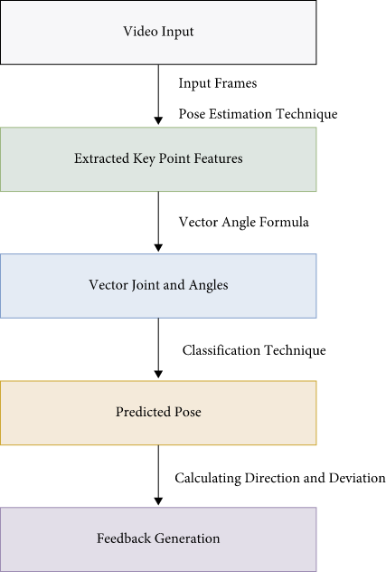

The remaining paper is organized as follows. The related work for yoga pose estimation is discussed. The datasets are outlined, and the section expounds on the proposed methodology to extract key points and features, classification, and feedback generation. The implementation details, evaluation measures of the proposed approach, and the runtime analysis are discussed. Finally, the conclusion and future scope are outlined.

#### **2. Background**

**Yoga: Its Origin, History and Development**

Introduction: Yoga is essentially a spiritual discipline based on an extremely subtle science, which focuses on bringing harmony between mind and body. It is an art and science of healthy living. The word ‘Yoga’ is derived from the Sanskrit root ‘Yuj’, meaning ‘to join’ or ‘to yoke’ or ‘to unite’. As per Yogic scriptures the practice of Yoga leads to the union of individual consciousness with that of the Universal Consciousness, indicating a perfect harmony between the mind and body, Man & Nature. According to modern scientists, everything in the universe is just a manifestation of the same quantum firmament. One who experiences this oneness of existence is said to be in yoga, and is termed as a yogi, having attained to a state of freedom referred to as mukti, nirvana or moksha. Thus the aim of Yoga is Self-realization, to overcome all kinds of sufferings leading to 'the state of liberation' (Moksha) or ‘freedom’ (Kaivalya). Living with freedom in all walks of life, health and harmony shall be the main objectives of Yoga practice. ”Yoga” also refers to an inner science comprising of a variety of methods through which human beings can realize this union and achieve mastery over their destiny.Yoga, being widely considered as an ‘immortal cultural outcome’ of Indus Saraswati Valley civilization – dating back to 2700 B.C., has proved itself catering to both material and spiritual upliftment of humanity.Basic humane values are the very identity of Yoga Sadhana.

**A Brief History and Development of Yoga:**

The practice of Yoga is believed to have started with the very dawn of civilization. The science of yoga has its origin thousands of years ago, long before the first religions or belief systems were born. In the yogic lore, Shiva is seen as the first yogi or Adiyogi, and the first Guru or Adi Guru.

Several Thousand years ago, on the banks of the lake Kantisarovar in the Himalayas, Adiyogi poured his profound knowledge into the legendary Saptarishis or "seven sages”. The sages carried this powerful yogic science to different parts of the world, including Asia, the Middle East, Northern Africa and South America. Interestingly, modern scholars have noted and marveled at the close parallels found between ancient cultures across the globe. However, it was in India that the yogic system found its fullest expression. Agastya, the Saptarishi who traveled across the Indian subcontinent, crafted this culture around a core yogic way of life.

A number of seals and fossil remains of Indus Saraswati valley civilization with Yotic motives and figures performing yoga indicate the presence of Yoga in India.The Number of seals and fossil remains of Indus Saraswati valley civilization with Yogic motives and figures performing Yoga Sadhana suggest the presence of Yoga in ancient India. The phallic symbols, seals of idols of mother Goddess are suggestive of Tantra Yoga. Presence of Yoga is available in folk traditions, Indus valley civilization, Vedic and Upanishadic heritage, Buddhist and Jain traditions, Darshanas, epics of Mahabharat and Ramayana, theistic traditions of Shaivas, Vaishnavas, and Tantric traditions. In addition, there was a primordial or pure Yoga which has been manifested in mystical traditions of South Asia. This was the time when Yoga was being practiced under the direct guidance of Guru and its spiritual value was given special importance. It was a part of Upasana and yoga sadhana was incorporated in their rituals. Sun was given highest importance during the vedic period. The practice of ‘Surya namaskara’ may have been invented later due to this influence. Pranayama was a part of daily ritual and to offer the oblation. Though Yoga was being practiced in the pre-Vedic period, the great Sage Maharshi Patanjali systematized and codified the then existing practices of Yoga, its meaning and its related knowledge through his Yoga Sutras. After Patanjali, many Sages and Yoga Masters contributed greatly for the preservation and development of the field through their well documented practices and literature.

Surya namaskar Historical evidences of the existence of Yoga were seen in the pre-Vedic period (2700 B.C.), and thereafter till Patanjali’s period. The main sources, from which we get the information about Yoga practices and the related literature during this period, are available in Vedas (4), Upanishads(108), Smritis, teachings of Buddhism, Jainism, Panini, Epics (2), Puranas (18) etc.

Tentatively, the period between 500 BC - 800 A.D. is considered as the Classical period which is also considered as the most fertile and prominent period in the history and development of Yoga. During this period, commentaries of Vyasa on Yoga Sutras and Bhagavad Gita etc. came into existence.This period can be mainly dedicated to two great religious teachers of India –Mahavir and Buddha. The concept of Five great vows – Pancha mahavrata- by Mahavir and Ashta Magga or eightfold path by Buddha - can be well considered as early nature of Yoga sadhana. We find its more explicit explanation in Bhagavad Gita which has elaborately presented the concept of Gyan yoga, Bhakti yoga and Karma Yoga. These three types of yoga are still the highest example of human wisdom and and even to day people find peace by following the methods as shown in Gita. Patanjali’s yoga sutra besides containing various aspects of yoga, is mainly identified with eight fold path of Yoga. The very important commentary on Yoga sutra by Vyasa was also written. During this very period the aspect of mind was given importance and it was clearly brought out through Yoga sadhana, Mind and body both can be brought under control to experience equanimity.The period between 800 A.D. - 1700 A.D. has been recognized as the Post Classical period wherein the teachings of great Acharyatrayas-Adi Shankracharya, Ramanujacharya, Madhavacharya-were prominent during this period. The teachings of Suradasa, Tulasidasa, Purandardasa, Mirabai were the great contributors during this period. The Natha Yogis of Hathayoga Tradition like Matsyendaranatha, Gorkshanatha, Cauranginatha, Swatmaram Suri, Gheranda, Shrinivasa Bhatt are some of the great personalities who popularized the Hatha Yoga practices during this period.

The period between 1700 - 1900 A.D. is considered as Modern period in which the great Yogacharyas- Ramana Maharshi, Ramakrishna Paramhansa, Paramhansa Yogananda, Vivekananda etc. have contributed for the development of Raja Yoga.This was the period when Vedanta, Bhakti yoga, Nathayoga or Hatha-yoga flourished. The Shadanga-yoga of Gorakshashatakam, Chaturanga-yoga of Hathayogapradipika, Saptanga-yoga of Gheranda Samhita, were the main tenents of Hatha-yoga.

Now in the contemporary times, everybody has conviction about yoga practices towards the preservation, maintenance and promotion of health. Yoga has spread all over the world by the teachings of great personalities like Swami Shivananda, Shri T.Krishnamacharya, Swami Kuvalayananda, Shri Yogendara, Swami Rama, Sri Aurobindo, Maharshi Mahesh Yogi, Acharya Rajanish, Pattabhijois, BKS. Iyengar, Swami Satyananda Sarasvati and the like.

B.K.S. Iyengar was the founder of the style of yoga known as "Iyengar Yoga" and was considered one of the foremost yoga teachers in the worldClearing Misconceptions:

For many, the practice of yoga is restricted to Hatha Yoga and Asanas (postures). However, among the Yoga Sutras, just three sutrasare dedicated to asanas. fundamentally, hatha yoga is a preparatory process so that the body can sustain higher levels of energy. The process begins with the body, then the breath, the mind, and the inner self.

Yoga is also commonly understood as a therapy or exercise system for health and fitness. While physical and mental health are natural consequences of yoga, the goal of yoga is more far-reaching. "Yoga is about harmonizing oneself with the universe. It is the technology of aligning individual geometry with the cosmic, to achieve the highest level of perception and harmony.”

Yoga does not adhere to any particular religion, belief system or community; it has always been approached as a technology for inner wellbeing. Anyone who practices yoga with involvement can reap its benefits, irrespective of one’s faith, ethnicity or culture.Traditional Schools of Yoga :These different Philosophies, Traditions, lineages and Guru-shishya paramparas of Yoga lead to the emergence of differnt Traditional Schools of Yoga e.g. Jnana-yoga, Bhakti-yoga, Karma-yoga, Dhyana-yoga, Patanjala-yoga, Kundalini-yoga, Hatha-yoga, Mantra-yoga, Laya-yoga, Raja-yoga, Jain-yoga, Bouddha-yoga etc. Each school has its own principles and practices leading to altimate aim and objectives of Yoga.

Yogic Practices for Health and Wellness:The widely practiced Yoga Sadhanas (Practices) are: Yama, Niyama, Asana, Pranayama, Pratyahara, Dharana, Dhyana (Meditation), Samadhi /Samyama, Bandhas & Mudras, Shat-karmas, Yukta-ahara, Yukta karma, Mantra japa, etc.Yama's are restraints and Niyama's are observances. These are considered to be prerequisites for the Yoga Sadhanas (Practices). Asanas, capable of bringing about stability of body and mind ‘ kuryat-tad-asanam-sthairyam...’ , consists in adopting various body (psycho-physical) patterns, giving ability to maintain a body position (a stable awareness of one’s structural existence) for a considerable length and period of time as well.

Different postures of Pranayama Pranayama consists in developing awareness of one’s breathing followed by willful regulation of respiration as the functional or vital basis of one’s existence. It helps in developing awareness of one’s mind and helps to establish control over the mind. In the initial stages, this is done by developing awareness of the ‘flow of in-breath and out-breath’ (svasa-prasvasa) through nostrils, mouth and other body openings, its internal and external pathways and destinations. Later, this phenomenon is modified, through regulated, controlled and monitored inhalation (svasa) leading to the awareness of the body space/s getting filled (puraka), the space/is remaining in a filled state (kumbhaka) and it’s getting emptied (rechaka) during regulated, controlled and monitored exhalation (prasvasa).

Pratyhara indicates dissociation of one’s consciousness (withdrawal) from the sense organs which helps one to remain connected with the external objects. Dharana indicates broad based field of attetion (inside the body and mind) which is usually understood as concentration. Dhyana (Meditation) is contemplation (focussed attention inside the body and mind) and Samadhi – integration.

Bandhas and Mudras are practices associated with pranayama. They are viewed as (the) higher Yogic practices mainly consisting on adopting certain body (psycho-physical) patterns along with (s well as) control over respiration.This further facilitates control over mind and paves way for higher yogic attainment.Shat-karmas are detoxification procedures, help to remove the toxins accumulated in the body and are clinical in nature.

Yuktahara (Right Food and other inputs) advocates appropriate food and food habits for healthy living. However, the practice of Dhyana (Meditation) helping in self-realization leading to transcendence is considered as the essence of Yoga Sadhana (The Practice of Yoga).

**The Fundamentals of Yoga Sadhana:**

Yoga works on the level of one’s body, mind, emotion and energy. This has given rise to four broad classifications of Yoga: karma yoga, where we utilize the body; bhakti yoga, where we utilize the emotions; gyana yoga, where we utilize the mind and intellect; and kriya yoga, where we utilize the energy.

Each system of Yoga we practice would fall within the gamut of one or more of these categories. Every individual is a unique combination of these four factors. "All the ancient commentaries on Yoga have stressed that it is essential to work under the direction of a Guru.” The reason being that only a Guru can mix the appropriate combination of the four fundamental paths, as is necessary for each seeker.Yoga Education:Traditionally, Yoga Education was imparted by knowledgeable, experienced, and wise persons in the families (comparable with the education imparted in convents in the west) and then by the Seers (Rishis/Munis/Acharyas) in Ashramas (compared with monasteries). Yoga Education, on the other hand, aims at taking care of the individual, the 'Being'. It is presumed that a good, balanced, integrated, truthful, clean, transparent person will be more useful to oneself, family, society, nation, nature and humanity at large. Yoga education is 'Being oriented'. Details of working with 'being oriented' aspect have been outlined in various living traditions and texts and the method contributing to this important field is known as 'Yoga'.

Present days, Yoga Education is being imparted by many eminent Yoga Institutions, Yoga Colleges, Yoga Universities, Yoga Departments in the Universities, Naturopathy colleges and Private trusts & societies. Many Yoga Clinics, Yoga Therapy and Training Centers, Preventive Health Care Units of Yoga, Yoga Research Centers etc. have been established in Hospitals, Dispensaries, Medical Institutions and Theoretical setups.

Different social customs and rituals in India, the land of Yoga, reflect a love for ecological balance, tolerance towards other systems of thought and a compassionate outlook towards all creations.Yoga Sadhana of all hues and colors is considered panacea for a meaningful life and living. Its orientation to a comprehensive health, both individual and social, makes it a worthy practice for the people of all religions, races and nationalities.

**Conclusion:**

Now-a-days, millions and millions of people across the globe have benefitted by the practice of Yoga which has been preserved and promoted by the great eminent Yoga Masters from ancient time to this date.The practice of Yoga is blossoming, and growing more vibrant every day.

***(Yoga: What You Need To Know)***

**What is yoga and how does it work?**

Yoga is an ancient and complex practice, rooted in Indian philosophy. It began as a spiritual practice but has become popular as a way of promoting physical and mental well-being.

Although classical yoga also includes other elements, yoga as practiced in the United States typically emphasizes physical postures (asanas), breathing techniques (pranayama), and meditation (dyana).

There are many different yoga styles, ranging from gentle practices to physically demanding ones. Differences in the types of yoga used in research studies may affect study results. This makes it challenging to evaluate research on the health effects of yoga.

Yoga and two practices of Chinese origin—tai chi and qi gong—are sometimes called “meditative movement” practices. All three practices include both meditative elements and physical ones.

**What are the health benefits of yoga?**

Help improve general wellness by relieving stress, supporting good health habits, and improving mental/emotional health, sleep, and balance.

Relieve low-back pain and neck pain, and possibly pain from tension-type headaches and knee osteoarthritis.

Help people who are overweight or obese lose weight.

Help people quit smoking.

Help people manage anxiety or depressive symptoms associated with difficult life situations.

Relieve menopause symptoms.

Help people with chronic diseases manage their symptoms and improve their quality of life.

Although there’s been a lot of research on the health effects of yoga, many studies have included only small numbers of people and haven’t been of high quality. Therefore, in most instances, we can only say that yoga has shown promise for particular health uses, not that it’s been proven to help.

**What does research show about yoga for wellness?**

Studies have suggested possible benefits of yoga for several aspects of wellness, including stress management, mental/emotional health, promoting healthy eating/activity habits, sleep, and balance.

**Can yoga help with pain management?**

Research has been done on yoga for several conditions that involve pain. Studies of yoga for low-back pain and neck pain have had promising results, and yoga is among the options that the American College of Physicians recommends for first-line treatment of chronic low-back pain. Preliminary evidence suggests that yoga may also be helpful for tension headaches and knee osteoarthritis pain.

**Is yoga a good way to lose weight?**

There’s evidence that yoga may help people lose weight.

**Can yoga help you quit smoking?**

There’s evidence that yoga may help people stop smoking.

**How does yoga affect mental health?**

There’s evidence that yoga may be helpful for anxiety associated with various life situations, such as medical conditions or stressful educational programs, and for depressive symptoms. The evidence on yoga’s impact on diagnosed mental health conditions is less promising.

**Can yoga help with menopause symptoms?**

Yoga seems to be at least as effective as other types of exercise in relieving menopause symptoms. A 2018 evaluation of 13 studies (more than 1,300 participants) of yoga for menopause symptoms found that yoga reduced physical symptoms, such as hot flashes, as well as psychological symptoms, such as anxiety or depression.

**Is yoga helpful for people with chronic diseases?**

There’s promising evidence that yoga may help people with some chronic diseases manage their symptoms and improve their quality of life. Thus, it could be a helpful addition to treatment programs.

**What does research show about practicing yoga during pregnancy?**

Physical activities, such as yoga, are safe and desirable for most pregnant women, as long as appropriate precautions are taken. Yoga may have health benefits for pregnant women, such as decreasing stress, anxiety, and depression.

**Does yoga have benefits for children?**

Research suggests that yoga may have several potential benefits for children.

**What are the risks of yoga?**

Yoga is generally considered a safe form of physical activity for healthy people when performed properly, under the guidance of a qualified instructor. However, as with other forms of physical activity, injuries can occur. The most common injuries are sprains and strains, and the parts of the body most commonly injured are the knee or lower leg. Serious injuries are rare. The risk of injury associated with yoga is lower than that for higher impact physical activities.

Older adults may need to be particularly cautious when practicing yoga. The rate of yoga-related injuries treated in emergency departments is higher in people age 65 and older than in younger adults.

**To reduce your chances of getting hurt while doing yoga:**

Practice yoga under the guidance of a qualified instructor. Practicing yoga by self-study without supervision has been associated with increased risks.

If you’re new to yoga, avoid extreme practices such as headstands, shoulder stands, the lotus position, and forceful breathing.

Be aware that hot yoga has special risks related to overheating and dehydration.

Pregnant women, older adults, and people with health conditions should talk with their health care providers and the yoga instructor about their individual needs. They may need to avoid or modify some yoga poses and practices. Some of the health conditions that may call for modifications in yoga include preexisting injuries, such as knee or hip injuries, lumbar spine disease, severe high blood pressure, balance issues, and glaucoma.

**YOGA IN INDIA**

can't beat doing yoga with the Himalayas in the background

Yoga means "union" in Sanskrit and has eight different elements of which hatha yoga (physical or active yoga), which Westerners most often use, is just one. In India, the practice of yoga is based on a comprehensive philosophy of man striving for harmony with himself and the world and encompasses breathing, meditation and exercise. In Western countries, it is associated most with the practice of asanas (postures). The sun salutation, or “surya namaskar” as it is known in Sanskrit, is a common yoga exercise in India.

In India, yoga has been incorporated into schools, hospitals, prisons and police academies. The Indian government has endorsed an effort to create a library of videos documenting the “correct” ways to strike more than 1,500 poses. [Source: Tanya Basu, The Atlantic Ocean, January 12, 2015]

Annie Gowen wrote in the Washington Post: “Although yoga has been a part of India’s heritage for centuries and Westerners flock to the country’s ashrams for enlightenment, it was only in the past two decades or so that yoga became trendy in India, with studios opening and Bollywood celebrities making fitness videos. Some of the credit goes to Baba Ramdev, the saffron-robed guru who popularized yoga and what he says are its health effects — he claims it can reverse homosexuality and cure cancer and swine flu — on a morning TV program watched by millions. Baba Ramdev also is a close ally of” Prime Minister Modi. [Source: Annie Gowen, Washington Post, December 2, 2014]

Websites and Resources: Yoga National Institutes of Health, US government, National Center for Complementary and Integrative Health (NCCIH), nccih.nih.gov/health/yoga/introduction ; Encyclopædia Britannica britannica.com ; Yoga: Its Origin, History and Development, Indian government mea.gov.in/in-focus-article ; Different Types of Yoga - Yoga Journal yogajournal.com ; Wikipedia article on yoga Wikipedia ; Medical News Today medicalnewstoday.com ; Yoga and modern philosophy, Mircea Eliade crossasia-repository.ub.uni-heidelberg.de ; India's 10 most renowned yoga gurus rediff.com ; Wikipedia article on yoga philosophy Wikipedia ; Yoga Poses Handbook mymission.lamission.edu ; George Feuerstein, Yoga and Meditation (Dhyana) santosha.com/moksha/meditation

**Short History of Yoga**

Historians are not sure when the idea or practice of yoga originated first appeared and debate on the topic is ongoing. Indus Valley stone carvings suggest that yoga was practiced as early as 3300 B.C. The term “yoga” is found in the Vedas, ancient India’s earliest known texts whose oldest parts date to around 1500 B.C.. Composed in Vedic Sanskrit, the Vedas are the oldest writings of Hinduism and Sanskrit literature.The term “yoga” in the Vedas refers mostly to a yoke, as in the yoke used to control animals. At times it refers to a chariot in the midst of battle and a warrior dying and transcending into heaven, being carried by his chariot to reach the gods and higher powers of being. During the Vedic period, ascetic Vedic priests carried out sacrifices, or yajna, in positions that some researchers argue are precursors to the yoga poses, or asanas, we know today. [Source: Lecia Bushak, Medical Daily, October 21, 2015 \^]

Joga Pradipika 16 Mayurasana, 1830

During the medieval era (A.D. 500-1500), different schools of yoga emerged. Bhakti yoga developed in Hinduism as a spiritual pathway that focused on living through love and devotion toward God. Tantrism (Tantra) emerged and began to influence medieval Buddhist, Jain, and Hindu traditions around the A.D. 5th century. According to White, new goals also emerged: “No longer is the practitioner’s ultimate goal liberation from suffering existence, but rather self-deification: one becomes the deity that has ben one’s object of meditation.” \^\

In the mid-19th century became intrigued with Indian culture in part because of the work by Theosophical Society. Yoga came to the attention of Westerners primarily through the efforts of Swami Vivekananda, a Hindu monk who toured Europe and the U.S. in the 1890s to spread knowledge about Hinduism among intellectuals. Vivekananda did much to bring attention to the Yoga Sutras, attributed to Patanjali and written sometime around A.D. 400, describing what he believed were the main yoga traditions of his time. The Yoga Sutras focused mainly on removing all excess thought from the mind and focusing on a singular thing; but they were later incorporated more heavily than any other ancient yoga writings in modern, “corporate” yoga. \^\

Krishnamacharya is the guru of the three hatha yoga masters most responsible for popularizing postural yoga throughout the world in the late twentieth century. Beginning in the 1950s, his three leading disciples—B. K. S. Iyengar, K. Pattabhi Jois, and T.K.V. Desikachar introduced their variations on his techniques that defined the postural yoga that has become so popular in Europe, the United States and many parts of the world since the 1960s. [Source: David Gordon White, “Yoga, Brief History of an Idea”]

**Machine Learning Introduction**

**What is Machine Learning**

Machine learning (ML) is a type of artificial intelligence (AI) that allows software applications to become more accurate at predicting outcomes without being explicitly programmed to do so. Machine learning algorithms use historical data as input to predict new output values.

Recommendation engines are a common use case for machine learning. Other popular uses include fraud detection, spam filtering, malware threat detection, business process automation (BPA) and Predictive maintenance.

**Importance of Machine Learning**

Machine learning is important because it gives enterprises a view of trends in customer behavior and business operational patterns, as well as supports the development of new products. Many of today's leading companies, such as Facebook, Google and Uber, make machine learning a central part of their operations. Machine learning has become a significant competitive differentiator for many companies.

**Types of Machine Learning**

Classical machine learning is often categorized by how an algorithm learns to become more accurate in its predictions. There are four basic approaches: supervised learning, unsupervised learning, semi-supervised learning and reinforcement learning. The type of algorithm data scientists choose to use depends on what type of data they want to predict.

Supervised learning:

In this type of machine learning, data scientists supply algorithms with labeled training data and define the variables they want the algorithm to assess for correlations. Both the input and the output of the algorithm is specified. Supervised learning can be grouped further in two categories of algorithms:

• Classification

• Regression

In the real-world, supervised learning can be used for Risk Assessment, Image classification, Fraud Detection, spam filtering, etc.

Unsupervised learning:

This type of machine learning involves algorithms that train on unlabeled data. The algorithm scans through data sets looking for any meaningful connection. The data that algorithms train on as well as the predictions or recommendations they output are predetermined. It can be further classifieds into two categories of algorithms:

• Clustering

• Association

Unsupervised learning finds a myriad of real-life applications, including data exploration, customer segmentation, recommender systems, target marketing campaigns, and data preparation and visualization, etc.

Semi-supervised learning:

This approach to machine learning involves a mix of the two preceding types. Data scientists may feed an algorithm mostly labeled training data, but the model is free to explore the data on its own and develop its own understanding of the data set. A Semi-Supervised algorithm assumes the following about the data

• Continuity Assumption

• Cluster Assumption

• Manifold Assumption

Some practical applications of semi-supervised learning are speech analysis, internet content classification, protein sequence classification, text documentation classifier etc.

Reinforcement learning:

Data scientists typically use reinforcement learning to teach a machine to complete a multi-step process for which there are clearly defined rules. Data scientists program an algorithm to complete a task and give it positive or negative cues as it works out how to complete a task. But for the most part, the algorithm decides on its own what steps to take along the way. There are three approaches to implement a Reinforcement Learning algorithm.

• Value-based

• Policy-based

• Model-based

Some applications of reinforcement learning are robotics for industrial automation, business strategy planning etc.

**Neural Networks**

Neural networks, also known as artificial neural networks (ANNs) or simulated neural networks (SNNs), are a subset of machine learning and are at the heart of deep learning algorithms. Their name and structure are inspired by the human brain, mimicking the way that biological neurons signal to one another.

Basics of Neural Networks

Neural networks, in the world of finance, assist in the development of such processes as time-series forecasting, algorithmic trading, securities classification, credit risk modeling, and constructing proprietary indicators and price derivatives.

The human brain is the inspiration behind neural network architecture. Human brain cells, called neurons, form a complex, highly interconnected network and send electrical signals to each other to help humans process information. Similarly, an artificial neural network is made of artificial neurons that work together to solve a problem. Artificial neurons are software modules, called nodes, and artificial neural networks are software programs or algorithms that, at their core, use computing systems to solve mathematical calculations.

Simple Neural Network Architecture

A basic neural network has interconnected artificial neurons in three layers:

Input Layer

Information from the outside world enters the artificial neural network from the input layer. Input nodes process the data, analyze or categorize it, and pass it on to the next layer.

Hidden Layer

Hidden layers take their input from the input layer or other hidden layers. Artificial neural networks can have a large number of hidden layers. Each hidden layer analyzes the output from the previous layer, processes it further, and passes it on to the next layer.

Output Layer

The output layer gives the final result of all the data processing by the artificial neural network. It can have single or multiple nodes. For instance, if we have a binary (yes/no) classification problem, the output layer will have one output node, which will give the result as 1 or 0. However, if we have a multi-class classification problem, the output layer might consist of more than one output node.

**Deep Neural Network Architecture**

Deep neural networks, or deep learning networks, have several hidden layers with millions of artificial neurons linked together. A number, called weight, represents the connections between one node and another. The weight is a positive number if one node excites another, or negative if one node suppresses the other. Nodes with higher weight values have more influence on the other nodes.

Theoretically, deep neural networks can map any input type to any output type. However, they also need much more training as compared to other machine learning methods. They need millions of examples of training data rather than perhaps the hundreds or thousands that a simpler network might need.

**Types of Neural Networks**

There are different kinds of deep neural networks. Examples include:

• Convolutional neural networks (CNNs)

• Recurrent neural networks (RNNs)

• Feedforward neural networks

• Autoencoder neural networks

**Applications of Neural Networks**

Neural Networks are regulating some key sectors including finance, healthcare, and automotive. As these artificial neurons function in a way similar to the human brain. They can be used for image recognition, character recognition and stock market predictions.

• Speech Recognition

• Character Recognition

• Human Face Recognition

• Signature Verification Application

• Stock-Exchange prediction

• Traveling Issues of sales professionals

• Image compression

# **What is Classification?**

### Classification is the process of predicting the class of given data points. Classes are sometimes called targets/ labels or categories. Classification predictive modeling is the task of approximating a mapping function (f) from input variables (X) to discrete output variables (y).

### For example, spam detection in email service providers can be identified as a classification problem. This is binary classification since there are only 2 classes as spam and not spam. A classifier utilizes some training data to understand how given input variables relate to the class. In this case, known spam and non-spam emails have to be used as the training data. When the classifier is trained accurately, it can be used to detect an unknown email.

### Classification belongs to the category of supervised learning where the targets are also provided with the input data. There are many applications in classification in many domains such as in credit approval, medical diagnosis, target marketing etc.

### 

### There are two types of learners in classification: lazy learners and eager learners**.**

## **1.Lazy learners**

### Lazy learners simply store the training data and wait until a testing data appear. When it does, classification is conducted based on the most related data in the stored training data. Compared to eager learners, lazy learners have less training time but more time in predicting.

### *Ex. k-nearest neighbor, Case-based reasoning*

## **2. Eager learners**

### Eager learners construct a classification model based on the given training data before receiving data for classification. It must be able to commit to a single hypothesis that covers the entire instance space. Due to the model construction, eager learners take a long time to train and less time to predict.

### *Ex. Decision Tree, Naive Bayes, Artificial Neural Networks*

# **Classification algorithms**

### There are a lot of classification algorithms available now but it is not possible to conclude which one is superior to the other. It depends on the application and nature of the available data set. For example, if the classes are linearly separable, the linear classifiers like Logistic regression, Fisher’s linear discriminant can outperform sophisticated models and vice versa.

## 

## **1. Decision Tree**

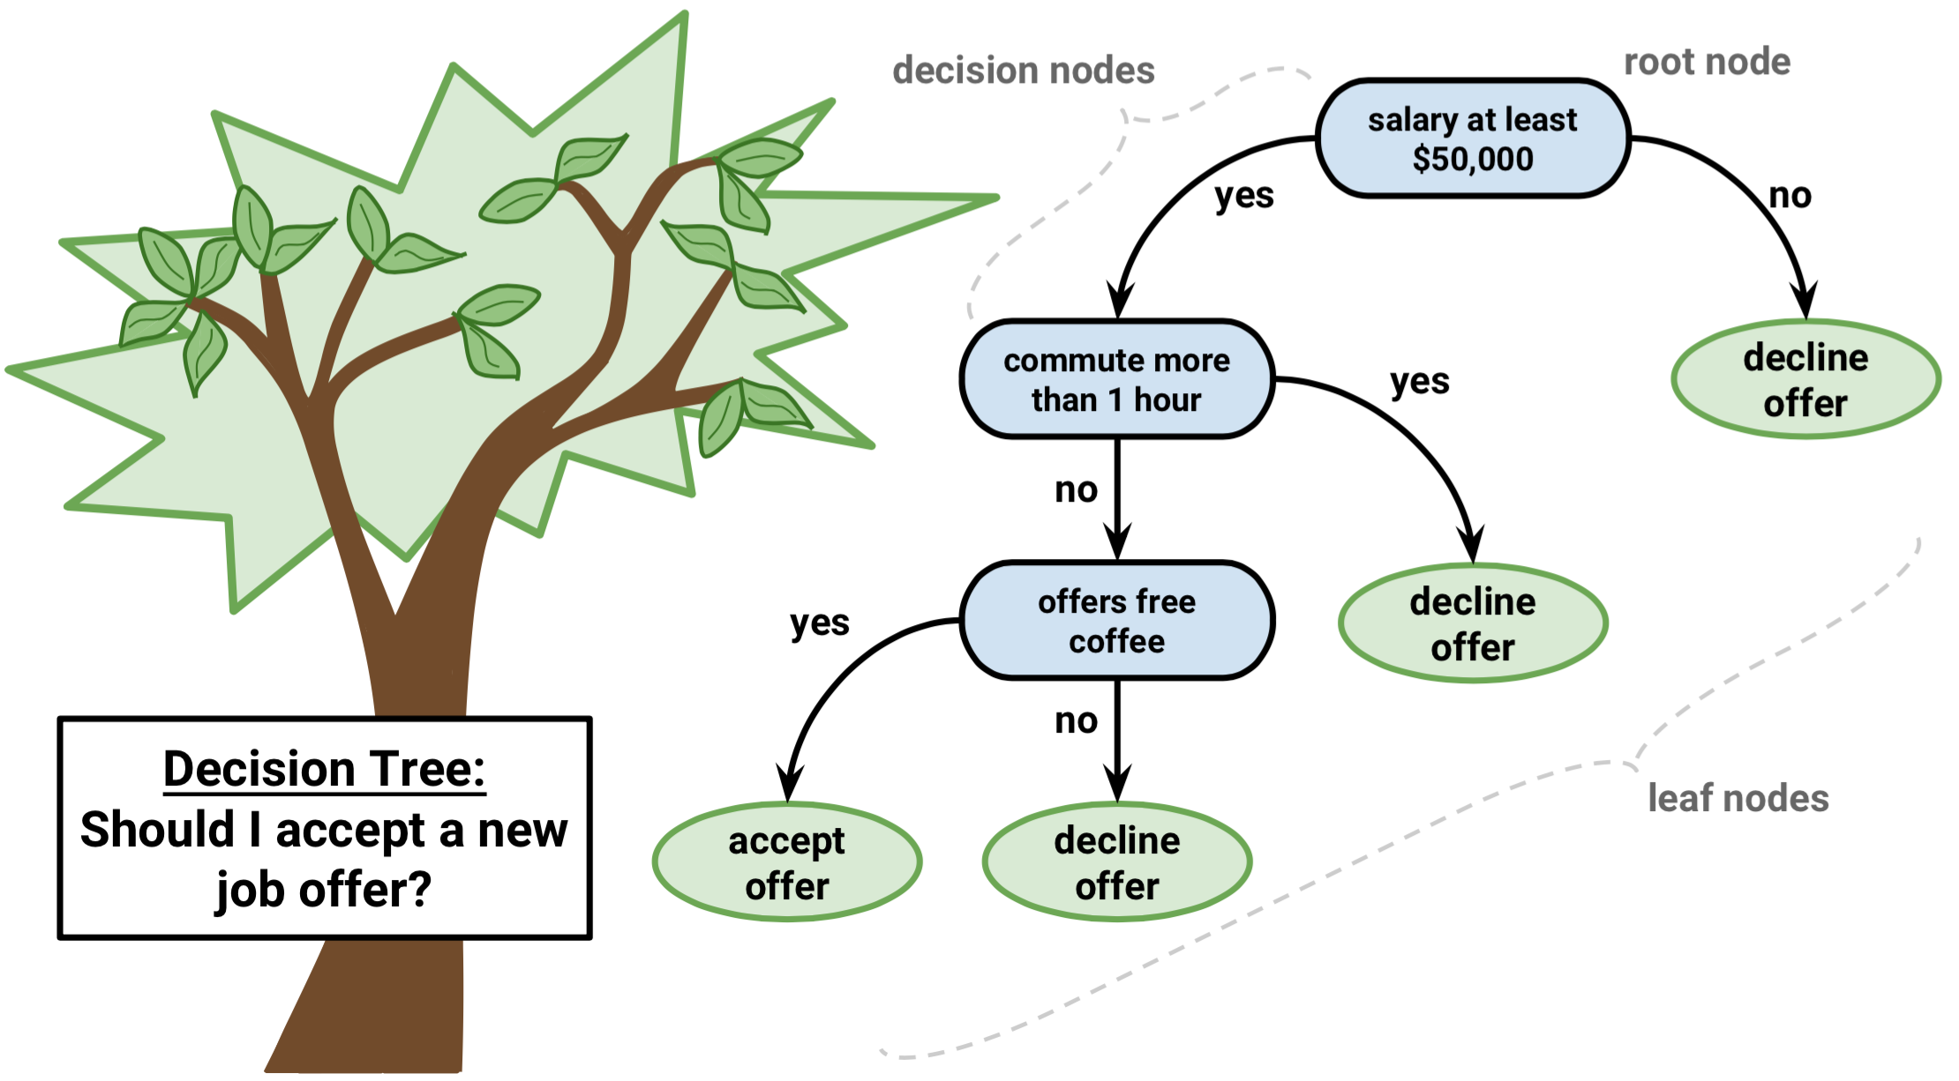

### Decision trees build classification or regression models in the form of a tree structure. It utilizes an if-then rule set which is mutually exclusive and exhaustive for classification. The rules are learned sequentially using the training data one at a time. Each time a rule is learned, the tuples covered by the rules are removed. This process is continued on the training set until meeting a termination condition.

### The tree is constructed in a top-down recursive divide-and-conquer manner. All the attributes should be categorical. Otherwise, they should be discretized in advance. Attributes in the top of the tree have more impact towards in the classification and they are identified using the information gain concept.

### A decision tree can be easily over-fitted generating too many branches and may reflect anomalies due to noise or outliers. An over-fitted model has a very poor performance on the unseen data even though it gives an impressive performance on training data. This can be avoided by pre-pruning which halts tree construction early or post-pruning which removes branches from the fully grown tree.

## **2. Naive Bayes**

### Naive Bayes is a probabilistic classifier inspired by the Bayes theorem under a simple assumption that the attributes are conditionally independent.

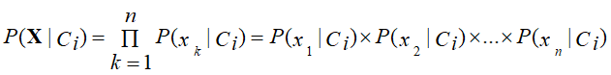

### The classification is conducted by deriving the maximum posterior which is the maximal P(Ci|X) with the above assumption applying to Bayes theorem. This assumption greatly reduces the computational cost by only counting the class distribution. Even though the assumption is not valid in most cases since the attributes are dependent, surprisingly Naive Bayes was able to perform impressively.

### Naive Bayes is a very simple algorithm to implement and good results have been obtained in most cases. It can be easily scalable to larger datasets since it takes linear time, rather than by expensive iterative approximation as used for many other types of classifiers.

### Naive Bayes can suffer from a problem called the zero probability problem. When the conditional probability is zero for a particular attribute, it fails to give a valid prediction. This needs to be fixed explicitly using a Laplacian estimator.

## **3. Artificial Neural Networks**

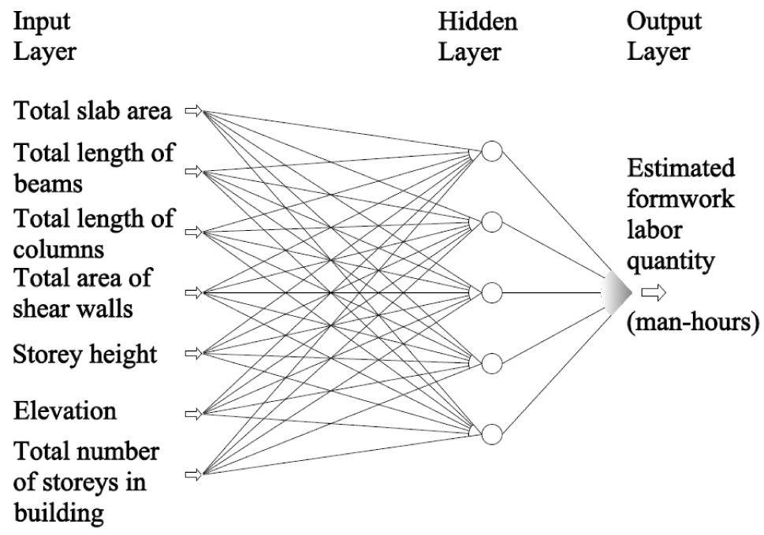

### Artificial Neural Network is a set of connected input/output units where each connection has a weight associated with it started by psychologists and neurobiologists to develop and test computational analogs of neurons. During the learning phase, the network learns by adjusting the weights so as to be able to predict the correct class label of the input tuples.

### There are many network architectures available now like Feed-forward, Convolutional, Recurrent etc. The appropriate architecture depends on the application of the model. For most cases feed-forward models give reasonably accurate results and especially for image processing applications, convolutional networks perform better.

### There can be multiple hidden layers in the model depending on the complexity of the function which is going to be mapped by the model. Having more hidden layers will enable us to model complex relationships such as deep neural networks.

### However, when there are many hidden layers, it takes a lot of time to train and adjust weights. The other disadvantage is the poor interpretability of the model compared to other models like Decision Trees due to the unknown symbolic meaning behind the learned weights.

### But Artificial Neural Networks have performed impressively in most of the real world applications. It has a high tolerance to noisy data and is able to classify untrained patterns. Usually, Artificial Neural Networks perform better with continuous-valued inputs and outputs.

### *All of the above algorithms are eager learners since they train a model in advance to generalize the training data and use it for prediction later.*

## **4. k-Nearest Neighbor (KNN)**

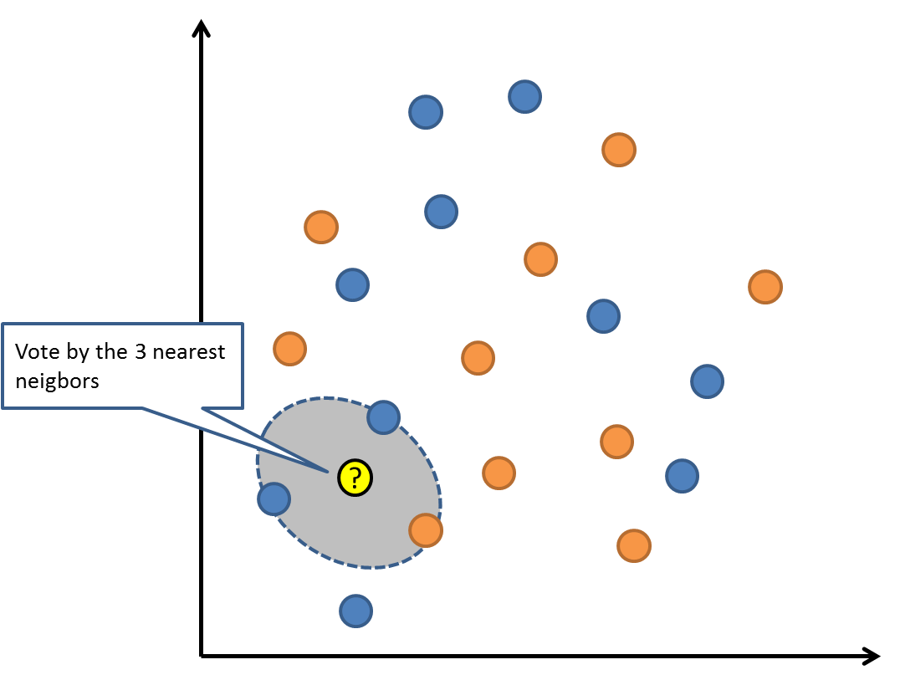

### k-Nearest Neighbor is a lazy learning algorithm which stores all instances corresponding to training data points in n-dimensional space. When an unknown discrete data is received, it analyzes the closest k number of instances saved (nearest neighbors)and returns the most common class as the prediction and for real-valued data it returns the mean of k nearest neighbors.

### In the distance-weighted nearest neighbor algorithm, it weighs the contribution of each of the k neighbors according to their distance using the following query giving greater weight to the closest neighbors.

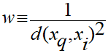

### Usually KNN is robust to noisy data since it is averaging the k-nearest neighbors.

## **4. Convolution Neural Network (CNN)**

|  |
| --- |
| Deep Learning – which has emerged as an effective tool for analyzing big data – uses complex algorithms and artificial neural networks to train machines/computers so that they can learn from experience, classify and recognize data/images just like a human brain does. Within Deep Learning, a Convolutional Neural Network or CNN is a type of artificial neural network, which is widely used for image/object recognition and classification. Deep Learning thus recognizes objects in an image by using a CNN. CNNs are playing a major role in diverse tasks/functions like image processing problems, computer vision tasks like localization and segmentation, video analysis, to recognize obstacles in self-driving cars, as well as speech recognition in natural language processing. As CNNs are playing a significant role in these fast-growing and emerging areas, they are very popular in Deep Learning. |
| cnn  Brain’s Architecture Inspired CNNs  A typical neural network will have an input layer, hidden layers, and an output layer. CNNs are inspired by the architecture of the brain. Just like a neuron in the brain processes and transmits information throughout the body, artificial neurons or nodes in CNNs take inputs, process them and send the result as output. The image is fed as input. The input layer accepts the image pixels as input in the form of arrays. In CNNs, there could be multiple hidden layers, which perform feature extraction from the image by doing calculations. This could include convolution, pooling, rectified linear units, and fully connected layers. Convolution is the first layer that does feature extraction from an input image. The fully connected layer classifies the object and identifies it in the output layer. “CNNs are feedforward networks in that information flow takes place in one direction only, from their inputs to their outputs. Just as artificial neural networks (ANN) are biologically inspired, so are CNNs. The visual cortex in the brain, which consists of alternating layers of simple and complex cells, motivates their architecture. CNN architectures come in several variations; however, in general, they consist of convolutional and pooling (or subsampling) layers, which are grouped into modules. Either one or more fully connected layers, as in a standard feedforward neural network, follow these modules,” describes a paper on “Deep Convolutional Neural Networks for Image Classification: A Comprehensive Review”, in the journal ‘Neural Computation’, which is published by MIT Press. |
| cnn  A Potent Tool Within Deep Learning   * CNNs have fundamentally changed our approach towards image recognition as they can detect patterns and make sense of them. They are considered the most effective architecture for image classification, retrieval and detection tasks as the accuracy of their results is very high. * They have broad applications in real-world tests, where they produce high-quality results and can do a good job of localizing and identifying where in an image a person/car/bird, etc., are. This aspect has made them the go-to method for predictions involving any image as an input. * A critical feature of CNNs is their ability to achieve ‘spatial invariance’, which implies that they can learn to recognize and extract image features anywhere in the image. There is no need for manual extraction as CNNs learn features by themselves from the image/data and perform extraction directly from images. This makes CNNs a potent tool within Deep Learning for getting accurate results. * According to the paper published in ‘Neural Computation’, “the purpose of the pooling layers is to reduce the spatial resolution of the feature maps and thus achieve spatial invariance to input distortions and translations.” As the pooling layer brings down the number of parameters needed to process the image, processing becomes faster even as it reduces memory requirement and computational cost. * While image analysis has been the most widespread use of CNNs, they can also be used for other data analysis and classification problems. Therefore, they can be applied across a diverse range of sectors to get precise results, covering critical aspects like face recognition, video classification, street/traffic sign recognition, classification of galaxy and interpretation and diagnosis/analysis of medical images, among others. |

# **Evaluating a classifier**

### After training the model the most important part is to evaluate the classifier to verify its applicability.

## **Holdout method**

### There are several methods that exist and the most common method is the holdout method. In this method, the given data set is divided into 2 partitions as test and train 20% and 80% respectively. The train set will be used to train the model and the unseen test data will be used to test its predictive power.

## **Cross-validation**

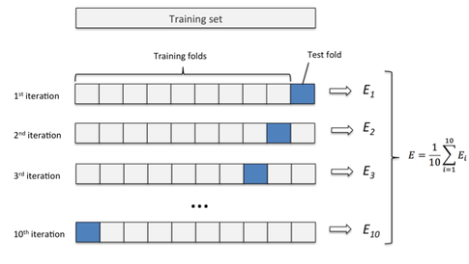

### Overfitting is a common problem in machine learning which can occur in most models. k-fold cross-validation can be conducted to verify that the model is not over-fitted. In this method, the data-set is randomly partitioned into k mutually exclusive subsets, each approximately equal size and one is kept for testing while others are used for training. This process is iterated throughout the whole k folds.

## **Precision and Recall**

### Precision is the fraction of relevant instances among the retrieved instances, while recall is the fraction of relevant instances that have been retrieved over the total amount of relevant instances. Precision and Recall are used as a measurement of the relevance.

## **ROC curve (Receiver Operating Characteristics)**

### ROC curve is used for visual comparison of classification models which shows the trade-off between the true positive rate and the false positive rate. The area under the ROC curve is a measure of the accuracy of the model. When a model is closer to the diagonal, it is less accurate and the model with perfect accuracy will have an area of 1.0

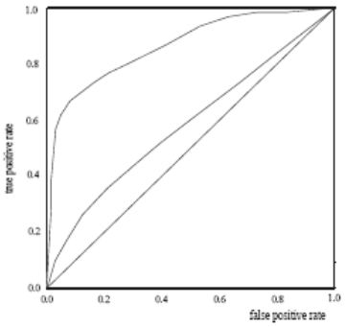

# **The evolution of image classification explained**

## **Introduction**

Recent research in deep learning has been largely inspired by the way our brain works. When you think of it, it is fascinating to know that with a given input, our brain processes features that let us know of the world that surrounds us.

As a result, architectures are crucial for us, not only because many challenges rely on the tasks we can perform with them. In fact, the design of the networks themselves points us out to the representation that researchers were looking for, in order to better learn from the data.

## **LeNet**

Before starting, let's note that we would not have been successful if we simply used a raw multi-layer perceptron connected to each pixel of an image. On top of becoming quickly intractable, this direct operation is not very efficient as pixels are spatially correlated.

Therefore, we first need to extract

1. meaningful and
2. low-dimensional features that we can work on.

And that's where convolutional neural networks come in the game!

To tackle this issue, Yann Lecun idea proceeds in multiple steps.

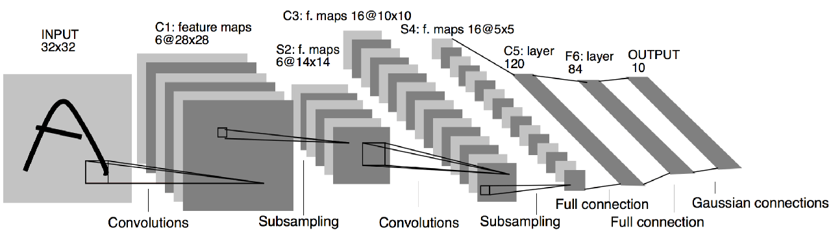

First, an input image is fed to the network. Filters of a given size scan the image and perform convolutions. The obtained features then go through an activation function. Then, the output goes through a succession of pooling and other convolution operations.

As you can see, features are reduced in dimension as the network goes on.

At the end, high-level features are flattened and fed to fully connected layers, which will eventually yield class probabilities through a softmax layer.

During training time, the network learns how to recognize the features that make a sample belong to a given class through backpropagation.

To give an example of what such a network can 'see': let's say we have an image of a horse. The first filters may focus on the animal's overall shape. And then as we go deeper, we can reach a higher level of abstraction where details like eyes and ears can be captured.

That way, ConvNets appear as a way to construct features that we would have had to handcraft ourselves otherwise.

## **AlexNet**

Then you might wonder, why have ConvNets not been trendy since 1998? The short answer is: we had not leveraged their full potential back then.

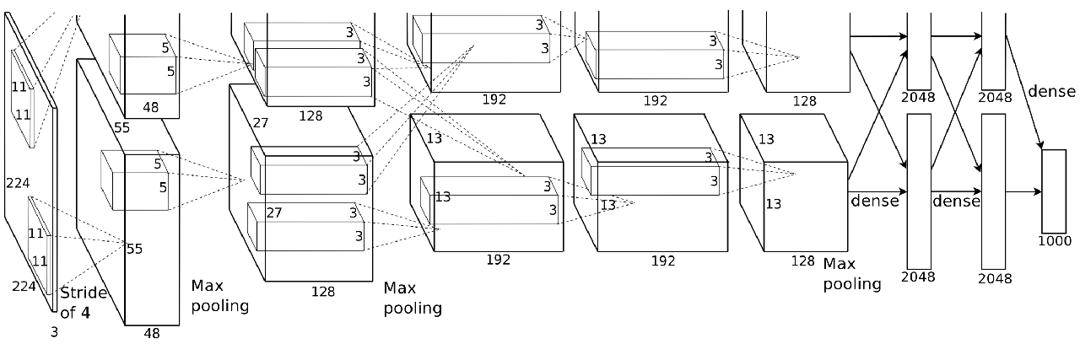

Here, AlexNet takes the same top-down approach, where successive filters are designed to capture more and more subtle features. But here, his work explored several crucial details.

1. First, Krizhevsky introduced better non-linearity in the network with the ReLU activation, whose derivative is 0 if the feature is below 0 and 1 for positive values. This proved to be efficient for gradient propagation.
2. Second, his paper introduced the concept of dropout as regularization. From a representation point of view, you force the network to forget things at random, so that it can see your next input data from a better perspective.

Just to give an example, after you finish reading this post, you will have most probably forgotten parts of it. And yet this is OK, because you will have only kept in mind what was essential.

Well, hopefully.

The same happens for neural networks, and leads the model to be more robust.

1. Also, it introduced data augmentation. When fed to the network, images are shown with random translation, rotation, crop. That way, it forces the network to be more aware of the attributes of the images, rather than the images themselves.

Finally, another trick used by AlexNet is to be deeper. You can see here that they stacked more convolutional layers before pooling operations. The representation captures consequently finer features that reveal to be useful for classification.

This network largely outperformed what was state-of-the-art back in 2012, with a 15.4% top-5 error on the ImageNet dataset.

## **VGGNet**

The next big milestone of image classification further explored the last point that I mentioned: going deeper.

And it works. This suggests that such networks can achieve a better hierarchical representation of visual data with more layers.

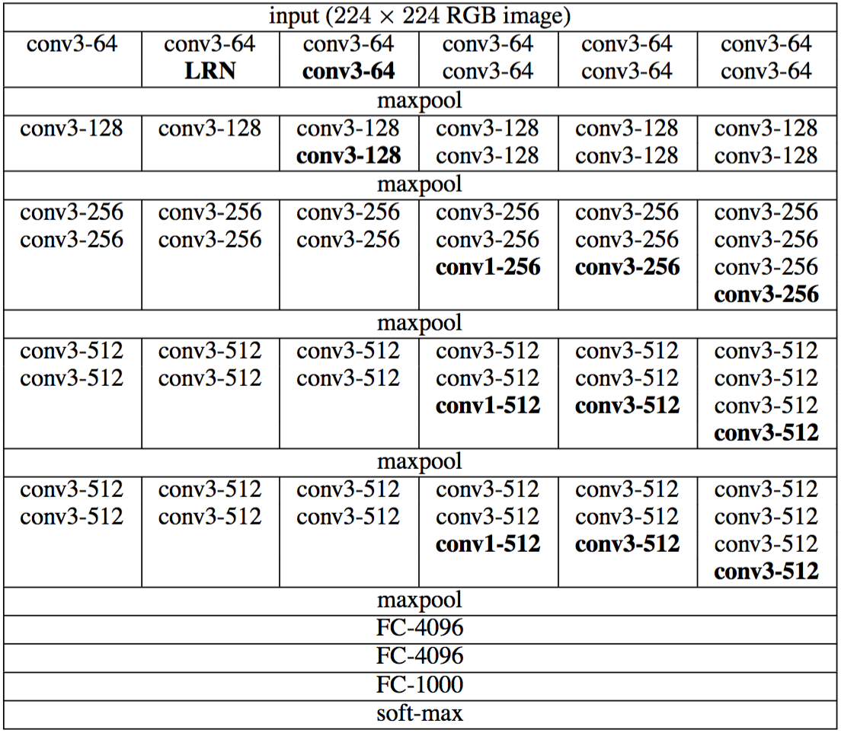

As you can see, something else is very special on this network. It contains almost exclusively 3 by 3 convolutions. This is curious, isn't?

In fact, the authors were driven by three main reasons to do so:

1. First, using small filters induces more non-linearity, which means more degrees of freedom for the network.
2. Second, the fact of stacking these layers together enables the network to see more things than it looks like. For example, with two of these, the network in fact *sees* a 5x5 receptive field. And when you stack 3 of these filters, you have in fact a 7x7 receptive field! Therefore, the same feature extraction capabilities as in the previous examples can be achieved on this architecture as well.
3. Third, using only small filters also limits the number of parameters, which is good when you want to go that deep.

Quantitatively speaking, this architecture achieved a 7.3% top-5 error on ImageNet.

## **GoogLeNet**

Next, GoogLeNet came into the game. It bases its success on its *inception modules*.

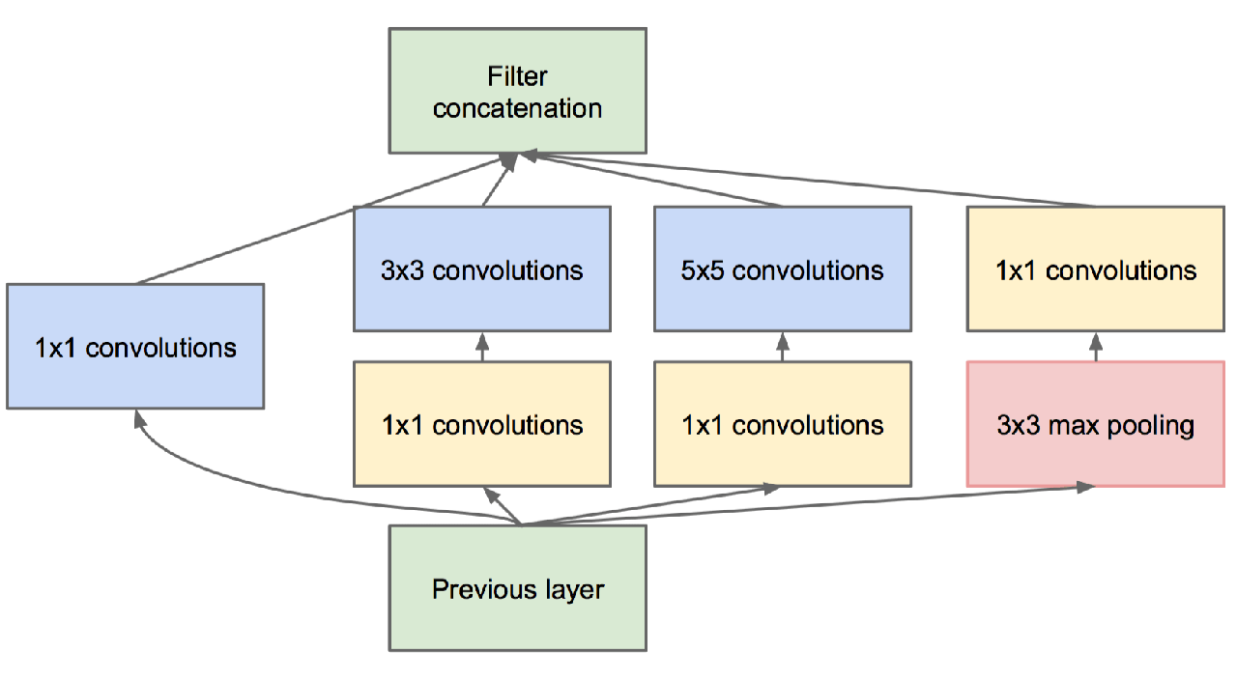

As you can see, convolutions with different filter sizes are processed on the same input, and then concatenated together.

From a representation point of view, this allows the model to take advantage of multi-level feature extraction at each step. For example, general features can be extracted by the 5x5 filters at the same time that more local features are captured by the 3x3 convolutions.

But then, you could tell me. Well that's great. But isn't that insanely expensive to compute?

And I would say: very good remark! Actually, the Google team had a brilliant solution for this: 1x1 convolutions.

1. On the one hand, it reduces the dimensionality of your features.
2. On the other hand, it combines feature maps in a way that can be beneficial from a representation perspective.

Then you could ask, why is it called *inception*? Well, you can see all of those modules as being networks stacked one over another inside a bigger network.

And for the record, the best GoogLeNet ensemble achieved a 6.7% error on ImageNet.

## **ResNet**

So all these networks we talked about earlier followed the same trend: going deeper. But at some point, we realize that stacking more layers does not lead to better performance. In fact, the exact opposite occurs. But why is that?

In one word: the gradient, ladies and gentlemen.

But don't worry, researchers found a trick to counter this effect. Here, the key concept developed by ResNet is *residual learning*.

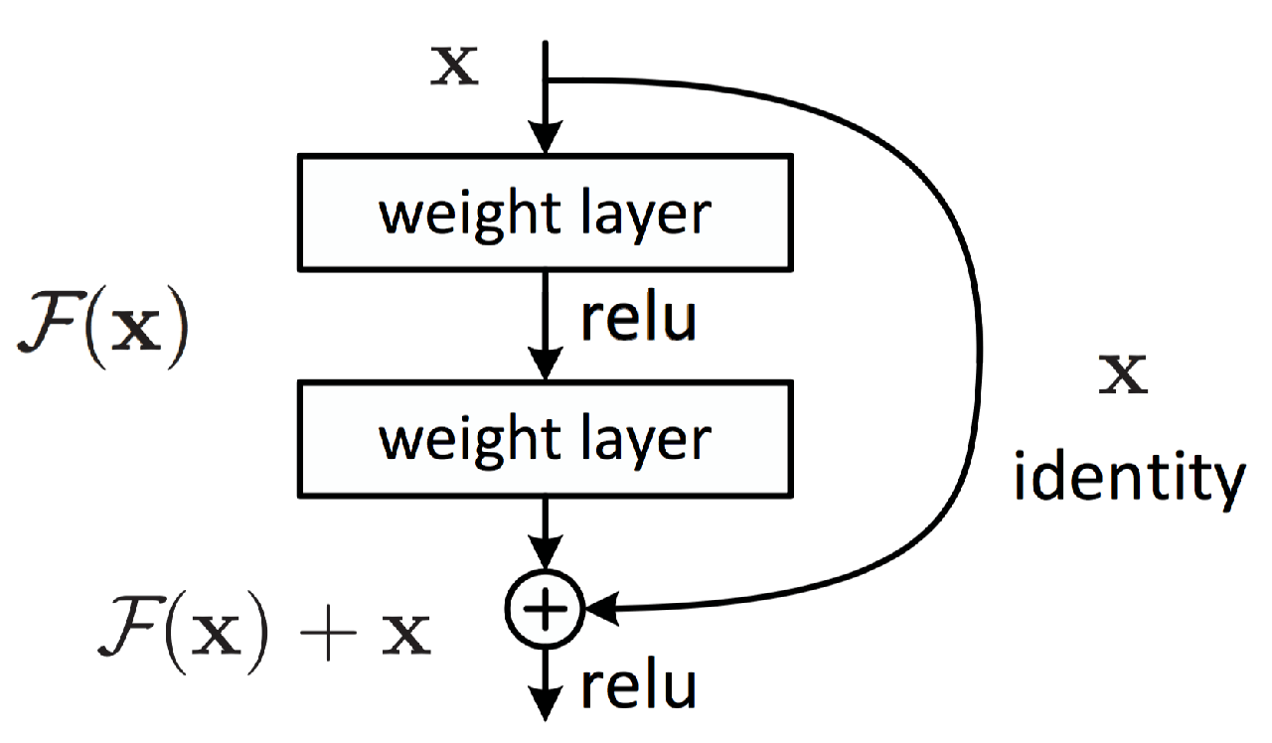

As you can see, every two layers, there is an identity mapping via an element-wise addition. This proved to be very helpful for gradient propagation, as the error can be backpropagation through multiple paths.

Also, from a representation point of view, this helps to combine different levels of features at each step of the network, just like we saw with the *inception modules*.

It is to this date one of the best performing networks on ImageNet, with a 3.6% top-5 error rate.

## **DenseNet**

An extension of this reasoning has been later proposed. DenseNet proposes entire blocks of layers connected to one another.

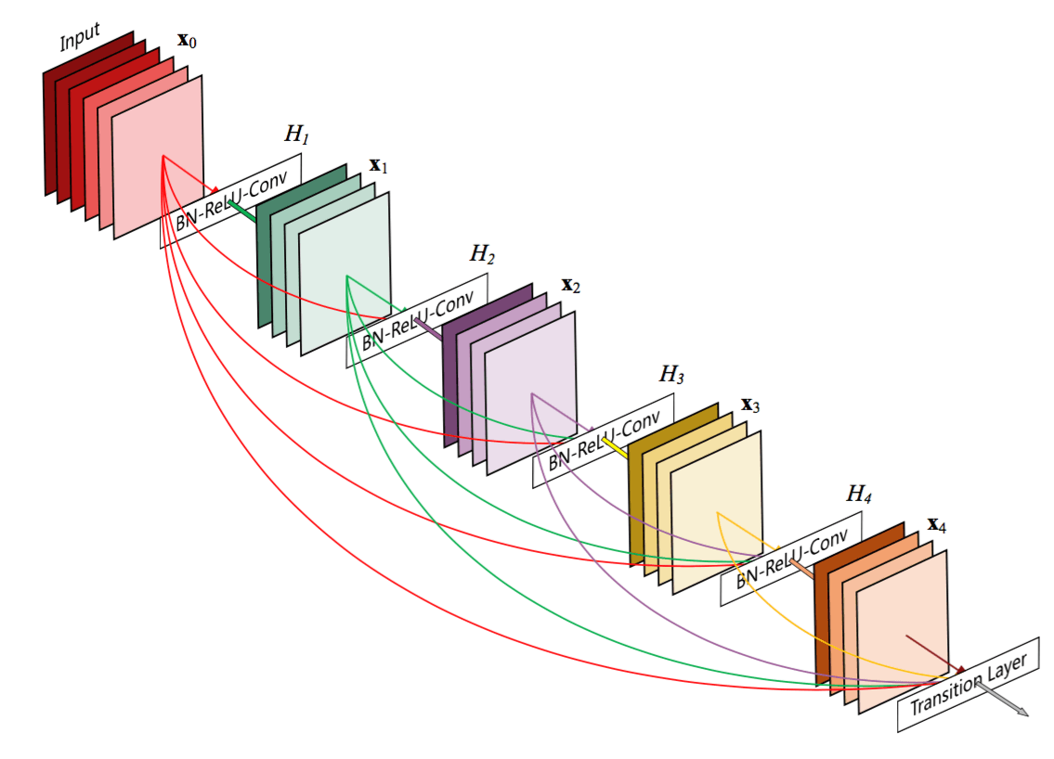

This contributes to diversifying a lot more the features within those blocks.

## **Conclusion**

A major pattern observed overall is that networks are designed to be deeper and deeper.

Computational tricks (ReLU, dropout, batch normalization) have been also introduced alongside them and had a significant impact in improving performance.

We have also seen the apparition of modules that are able to capture rich features at each step of the network.

Finally, another major point is the increasing use of connections between the layers of the network, which helps for producing diverse features and revealed to be useful for gradient propagation.

**Pose Estimation**

Pose estimation is a significant strategy that has been actively researched in various fields. For example, the strategy has been adopted for motion capture in moviemaking, and character control in video games. It can also be applied to implement the user interfaces of mobile devices through human poses. Therefore, this paper compares and analyzes four popular pose estimation models, namely, OpenPose, PoseNet, MoveNet Lightning, and MoveNet Thunder, using pre-classified images. The results show that MoveNet Lightning was the fastest, and OpenPose was the slowest among the four models. But OpenPose was the only model capable of estimating the poses of multiple persons. The accuracies of OpenPose, PoseNet, MoveNet Lightning, and MoveNet Thunder were 86.2%, 97.6%, 75.1%, and 80.6%, respectively.

Introduction

Pose refers to the movement of a part of the human body, such as the hands, arms, head, and face, that expresses an idea or a feeling. It is a form of non-verbal communication often used consciously, or unconsciously in daily life. The common poses include handshaking, clapping, and dancing. If these poses are taken as the user interface of devices, e.g., desktops, laptops, and smartphones, it is possible to express intentions more directly and obtain an extended experience. Apart from that, poses can be applied to virtual reality (VR), augmented reality (AR) and mixed reality (MR) to enhance the immersion and presence of users. The pose-based user interfaces boast another advantage: numerous poses can be defined, and used to interact with the devices.

Pose estimation, the key to pose recognition in user interfaces, can be utilized in various manners. In the field of movies and video games, poses are commonly estimated by motion capture. Actors are required to either wear a suit with multiple sensors or attach markers to their bodies. During the performance, computer graphics are added to the captured media, making the expression vivid and lively. In the field of video games, Nintendo released the Wii, a home video game console, in 2006 [1]. The controller of the console uses an infrared sensor, and allows operations on the screen, such as cursor movement on a personal computer (PC). Besides infrared sensors, various built-in sensors enable us to play realistic games, such as tennis, golf, and boxing. In 2010, Microsoft launched Kinect, a peripheral device of Xbox 360 [2]. Kinect relies on a camera to estimate poses and a microphone to recognize voices. As a result, users can play games without the aid of additional controllers. Although not embedded in the latest Xbox, Kinect continues to be used for military and research purposes. Similarly, the PlayStation camera [3], move controller [4], and VIVE tracker [5] are employed in video games.

In addition to motion capture and video games, pose estimation plays a significant role in smartphones. Despite the expansion of the screen and smartphones itself, and the reduction of the bezel, the current size of smartphones is not enough for various expressions. To overcome the limitation, pose estimation could be adopted to provide a convenient input method, in replacement of the traditional touch approach [6]. For example, Samsung Health [7] and Apple Fitness+ [8] could adopt pose estimation to inform users about the correctness of their poses via a mobile device. Pose estimation can also be employed to interact with AR contents [9] on smartphones.

OpenPose, PoseNet, and MoveNet are available for pose estimation on mobile devices. All these methods estimate poses through deep learning of camera inputs, eliminating the need for sensors, and therefore apply to most devices.

To the best of our knowledge, this paper is the first attempt to summarize and compare the features and prospects of OpenPose, PoseNet, and MoveNet, which are common tools for pose estimation on mobile devices. The remainder of this paper is organized as follows: Section 2 summarizes the functions of OpenPose, PoseNet, and MoveNet for a better understanding of the research; Section 3 evaluates the three models in terms of the features and performance in the same environment; Section 4 puts forward the conclusions.

Models

Poses are generally estimated by top-down or bottom-up methods. The top-down method first discovers a person in the input, and derives the pose in his/her bounding box. The bottom-up method infers the pose from all the key-points in the input, as well as the relationship between these points.

## 

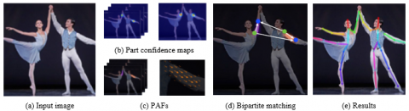

**Figure 1. Overall process of OpenPose**

OpenPose

In 2017, Cao et al. [10] at Carnegie Mellon University proposed OpenPose. This open source model marks the first attempt to estimate multi-person poses in the real time. It uses the bottom-up method to overcome the limitations of the top-down method. The flow of OpenPose is illustrated in Figure 1.

As shown in Figure 1 (a), two-dimensional (2D) images/videos are imported to the model. Then, a confidence map is obtained from the input. Through non-maximum suppression (NMS), the candidates for the body are identified in the confidence map. After identifying an object, a bounding box is created to contain the object, and the probability of the object is set as a score. Next, the scores are sorted in descending order, and the redundant bounding boxes are removed by the following criterion: the intersection of union (IoU) is greater than the threshold, which means the two bounding boxes identify the same object. The IoU refers to the ratio of the overlapping region to the combined region. The removal of redundant bounding boxes is known as NMS. On this basis, OpenPose creates part affinity fields (PAFs), a set of flow fields representing the relationships between parts of many persons. Finally, bipartite matching is performed on the candidates using confidence maps and PAFs, producing full-body poses.

OpenPose and Alpha-Pose are still under research [11, 12]. OpenPose was initially written in C++, and recently in Python. The applicability of different versions depends on the central processing unit (CPU) or Unity [13].

PoseNet

PoseNet is an open source machine learning model created by Google Creative Lab. Capable of estimating human poses in the real time [14], the model works on the recently released COCO person key-point detection dataset, which tracks the key-points of the entire body.

Single-person pose estimation uses four elements as input: an input image, an image scale factor, a horizontal flip, and an output stride. The single-person detection algorithm is faster and simpler than the multi-person detection algorithm. Besides the four elements above, three other elements are required in the input of multi-person pose estimation: the maximum number of detected poses, the threshold for pose confidence score, and the NMS radius. These additional elements improve the accuracy of multi-person pose estimation. The estimation results include pose confidence scores and key-points. Figure 2 illustrates the flow of PoseNet.

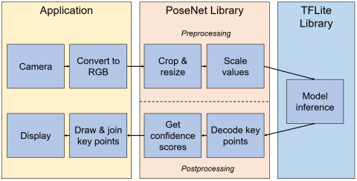

**Figure 2. Flow of PoseNet [15]**

As shown in Figure 2, PoseNet for mobile devices operating on Android and iOS has been developed under TensorFlow Lite [15-17]. The overall pipeline is similar to the JavaScript version. Currently, there is a face tracker called Facemesh, which combines PoseNet into a pose animator [18]. Facemesh can animate full-body characters, similar to motion capture.

MoveNet

MoveNet [19, 20] is a Google-based inference model developed by IncludeHealth, a digital health company [21]. IncludeHealth unveiled the model in 2021, and solicited help from Google to support remote treatment of patients. Similar to PoseNet, the web version of MoveNet uses TensorFlow.js, and the mobile version uses TensorFlow Lite. There are two versions of MoveNet: the performance-oriented Lightning [22], and the accuracy-oriented Thunder [23]. The two models differ in input size and depth multiplier. In terms of input, Lightning receives a video or an image of a fixed size (192×192) and three channels, and employs 1.0 depth multiplier. In contrast, Thunder receives an input of the size 256×256 and three channels, and employs a 1.75 depth multiplier. The depth multiplier changes the number of channels of the input video/image, which generally adopts the red-green-blue (RGB) format. Yet feature maps can also be regarded as one channel in each layer. Meanwhile, Thunder has 1.75 times more layers for deep learning than Lightning. Hence, it performs 1.75 times more calculations.

MoveNet is a bottom-up model that relies on TensorFlow object detection API and MobileNet V2 as a feature extractor. In the TensorFlow object detection API, there are multiple detection models supporting TensorFlow 1 and TensorFlow 2. MoveNet follows CenterNet [24, 25], a detection API [26]. Different from the standard anchor (bounding box)-based detection model, CenterNet takes the center point as the only anchor, and searches for and classifies objects by processing regional proposals, rather than inferring objects from the IoU value. Without requiring NMS, CenterNet recognizes the difference between objects in one stage, and exhibits a high performance.

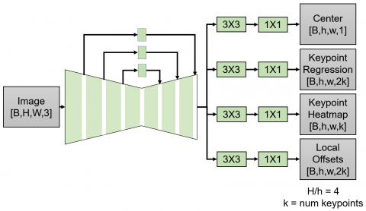

**Figure 3. Flow of MoveNet [19]**

As shown in Figure 3, MoveNet [19] calculates all four processes simultaneously. Once a person center heatmap is prepared to identify each person, the location with the highest score is selected. Then, a set of key-points for the person is initialized based on the key-points obtained through regression. A person is identified, when the regression fits the arrangement of prepared key-points into a person. Furthermore, each pixel is multiplied by a weight, which is inversely proportional to the distance from the regressed key-point. In this way, the key-points from the persons in the background are excluded from the computation. In the end, the set of key-points is finalized according to the maximum heatmap values in each key-point channel.

Results and Discussion

Table 1 compares the basic specifications of OpenPose, PoseNet, and MoveNet. It can be observed that the number of key-points is the most prominent difference between these models. PoseNet provides a total of 17 key-points: 5 in the face and 12 in the body. MoveNet has the same key-points as PoseNet. OpenPose supports 137 key-points: 25 in the body, including the foot, 21 in each hand, and 70 in the face. Overall, OpenPose can track the body in greater details than the other two models. Another difference lies in the pose estimation method: PoseNet uses the top-down method, while OpenPose and MoveNet adopt the bottom-up method. The top-down method estimates a pose within a person’s bounding box after detecting the person. On the contrary, the bottom-up method predicts the key-points of persons in the input, and estimates the pose from the correlation between the key-points.

|  |  |  |  |
| --- | --- | --- | --- |
|  | OpenPose | PoseNet | MoveNet |
| Detection Parts | Body, Foot, Hand, Face | Body,  Part of face | Body,  Part of face |
| Detection No. | Many | One | One |
| Key-points | 137 | 17 | 17 |
| Operation | Real-time | Real-time | Real-time |
| Method | Bottom-up | Top-down | Bottom-up |

**Table 1. Basic specifications of OpenPose, PoseNet, and MoveNet**

These models can be applied to mobile devices in the following steps:

Step 1. The outside view is imported via the camera of the mobile phone, where the screen presents the preview of the application.

Step 2. The application captures a short moment of the preview.

Step 3. The captured contents are entered into the estimation model.

Step 4. The results of the above step are displayed on the preview screen.

Step 5. The application shuts down if the user presses the back button.

Step 6. Otherwise, Steps 2-5 are repeated.

To compare the three models fairly and accurately, the input method of comparative applications was changed, and the same scenes were delivered to OpenPose, PoseNet, and MoveNet. The images of the COCO and MPII datasets [27, 28] (Figure 4) were grouped, and used for the comparative analysis.

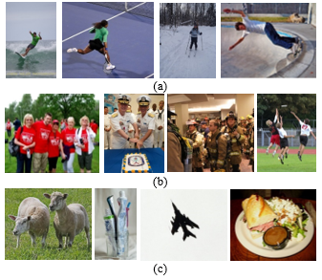

**Figure 4. Examples of image groups**

**(a) First group with a single person (b) Second group with multiple persons (c) Third group without any person**

As shown in Figure 4, the first group consists of images with only one person. This group was used to compare the performance of OpenPose, PoseNet, and MoveNet.

The second group consists of images with multiple persons. Since the mobile versions of PoseNet and MoveNet only apply to single-person pose estimation, the two models cannot be compared accurately with OpenPose on the second group of images.

The third group comprises images, which contain no person, but include elements like animals, dolls, food, and natural environment. This group was adopted to verify whether the three models can estimate poses, when there is no person in the image, and check if their performance would be affected.

Each of the three groups includes 1,000 different images. The performance of each model was measured by:

Table 2 summarized the results of all three models. Note that all results were rounded to the third decimal place.

|  |  |  |  |  |
| --- | --- | --- | --- | --- |
| **Group** | **OpenPose** | | **PoseNet** | |
| **Total time** | **SD** | **Total time** | **SD** |
| **1st** | **649.368** | **13.757** | **78.289** | **0.252** |
| **2nd** | **643.384** | **21.915** | **77.732** | **0.630** |
| **3rd** | **637.856** | **16.960** | **69.675** | **0.464** |

|  |  |  |  |  |
| --- | --- | --- | --- | --- |
| **Group** | **MoveNet Lightning** | | **MoveNet Thunder** | |
| **Total time** | **SD** | **Total time** | **SD** |
| **1st** | **55.362** | **0.652** | **141.435** | **8.186** |
| **2nd** | **56.122** | **1.086** | **141.005** | **3.832** |
| **3rd** | **48.891** | **1.746** | **137.482** | **0.717** |

**Table 2. Total time (unit: s) to estimate 1,000 images within a group and its standard deviation**

As shown in Table 2, all models achieved the best performance on the images of the third group, for the images do not contain any person. PoseNet had the smallest standard deviation, i.e., the smallest performance fluctuation between runs.

As shown in Table 3, the models can be ranked in descending order of performance as MoveNet Lightning, PoseNet, MoveNet Thunder, and OpenPose. This is because OpenPose is a multi-person pose estimation model, and the bottom-up method is slower than the top-down method.

|  |  |  |  |  |
| --- | --- | --- | --- | --- |
| **Models** | **OpenPose** | **PoseNet** | **MoveNet Lightning** | **MoveNet Thunder** |
| **Average time** | **643.536** | **75.232** | **53.458** | **139.974** |

**Table 3. Mean time to estimate 1,000 images (unit: s)**

|  |  |  |  |  |
| --- | --- | --- | --- | --- |
| **Model** | **OpenPose** | **PoseNet** | **MoveNet Lightning** | **MoveNet Thunder** |
| **Group 1** | **78.5%** | **96.7%** | **78.7%** | **79.5%** |
| **Group 3** | **93.8%** | **98.4%** | **71.5%** | **81.6%** |
| **Average** | **86.2%** | **97.6%** | **75.1%** | **80.6%** |

**Table 4. Pose estimation accuracies on images within the first and third groups**

As shown in Table 4, PoseNet had the highest accuracy, followed by OpenPose, and then MoveNet Thunder/ Lightning.

Next, the multi-person pose estimation effect of OpenPose was verified. The relevant results are displayed in Figure 5.

## 

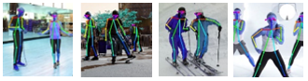

**Figure 5. Results of OpenPose**

As shown in Figure 5, OpenPose successfully identified the multiple persons, and accurately estimated the poses within each image. But PoseNet and MoveNet failed to find such persons.

A part of the execution results is reported in Figure 6, where the columns are in the order of original, OpenPose, PoseNet, and MoveNet Lightning/ Thunder, the first and second rows are the images, where the poses are successfully estimated, and the third row is the results of the third group. As shown in Figure 6, PoseNet and MoveNet Thunder output human poses, although no pose is included in the third group.

Figure 7 shows the images in the first group, where the poses are incorrectly estimated. The results of PoseNet are presented in subgraphs (a) and (b): In both cases, PoseNet and MoveNet successfully inferred the poses, but OpenPose failed. The results of OpenPose are presented in subgraphs (c) and (d): In the case (c), both MoveNet models successfully inferred the pose, while OpenPose estimated only a part of the arm, and PoseNet failed to estimate the pose, as it could not recognize the person due to rotation; In the case (d), OpenPose recognized the doll as a human, and estimated the doll poses in addition to human poses, yet PoseNet and MoveNet estimated only human poses.

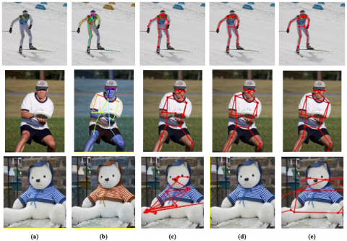

**Figure 6. A part of the execution results (a) Original image (b) Results of OpenPose (c) Results of PoseNet (d) Results of y MoveNet Lightning (e) Results of MoveNet Thunder**

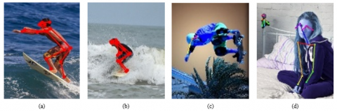

**Figure 7. Incorrect outputs on the first group (a)(b) Results of PoseNet (c)(d) Results of OpenPose**

Conclusion

The pose estimation on mobile devices is crucial, because it supports manipulations that cannot be performed with only a touch interface. For example, smartphones with Android 4.3 Jelly Bean or newer versions have an additional function called Smart Stay, which tracks user eyes on the phone. Another emerging example is the function of Smart Scrolling, which captures user eyes and phone tilt. Moreover, the Motion Sense function of Pixel 4 enables media control without touching the phone, even if the screen is turned off. In addition, many other functions can be realized through using pose estimation. As a result, OpenPose, PoseNet, and MoveNet boast a great potential in mobile device applications. However, their advantages and disadvantages have not yet been investigated.

This paper compares the mobile version of OpenPose, PoseNet, and MoveNet in terms of features and performance, using pre-classified images. All models could use normal cameras without any specific sensors. The comparison reveals that MoveNet Lightning was the fastest model. OpenPose was 12 times slower than MoveNet, but it could estimate the poses of multiple persons. Meanwhile, PoseNet achieved the highest accuracy. The limitation of our research is that the model performance was merely compared on images, and the results of the camera input were not measured, which will be considered in future research. Also, MoveNet MultiPose was recently developed and was unable to be compared in this paper. We consider it as the next research.

## What is PoseNet?

Posenet is a real-time pose detection technique with which you can detect human beings’ poses in Image or Video. It works in both cases as single-mode(single human pose detection) and multi-pose detection(Multiple humans pose detection). In simple words, Posenet is a deep learning TensorFlow model that allows you to estimate human pose by detecting body parts such as elbows, hips, wrists, knees, ankles, and form a skeleton structure of your pose by joining these points.

## How does PoseNet work?

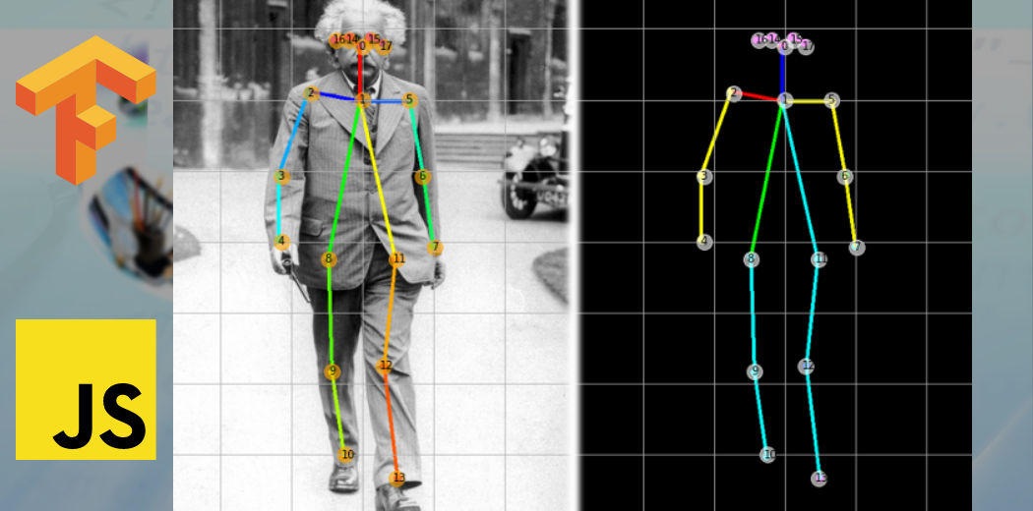

PoseNet is trained in MobileNet Architecture. MobileNet is a Convolutional neural network developed by Google which is trained on the ImageNet dataset, majorly used for Image classification in categories and target estimation. It is a lightweight model which uses depthwise separable convolution to deepen the network and reduce parameters, computation cost, and increased accuracy. There are tons of articles related to MobileNet that you can find on google.

The pre-trained models run in our browsers, that is what differentiates posenet from other API-dependent libraries. Hence, anyone with a limited configuration in a laptop/desktop can easily make use of such models and built good project

Introduction

Deep learning is a subset of Machine Learning and Artificial Intelligence that imitates the way humans gain certain types of knowledge. It is essentially a neural network with three or more layers. deep-learning helps to solve many artificial intelligence applications that help improve automation, performing analytical and physical tasks without human intervention, thus creating disruptive applications and techniques. One such application is Human Pose detection where deep learning takes its place.

## Applications of PoseNet in the Real-world used by organizations

1) Used in Snapchat filters where you see the tongue, aspects, glimpse, dummy faces.

2) Fitness apps are like a cult which is used to detect your exercise poses.

3) A very popular Instagram Reels uses posture detection to provide you with different features to apply on your face and surrounding.

4) Virtual Games to analyze shots of players.

**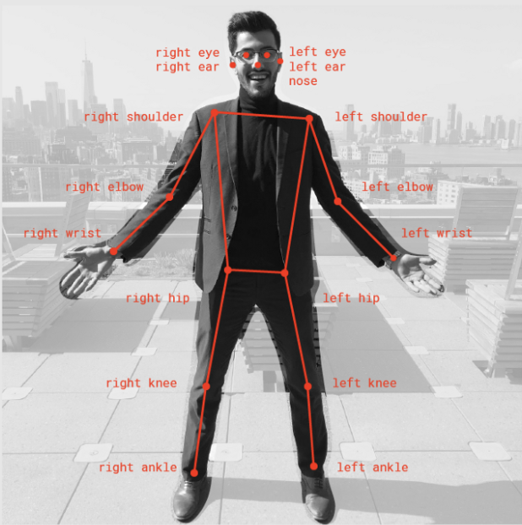*join points***

#### 

#### **3. Related Work**

Human activity recognition has been employed in a variety of applications, including robotics and computer engineering. References [16, 17] use randomized trees (random forests) for detecting human activities with the help of sensors. Reference [18] uses hidden Markov models and recognized body parts for human activity recognition. This method is used for the recognition of 6 home activities, which achieved an accuracy of 97.16 percent. This method is used at smart homes for monitoring services. [19] It uses environmental background sounds for human activity recognition where wearable sensors that detect sounds are used, which achieved an accuracy of 96.9 percent.

Significant work has been done in developing automated systems, which analyze yoga and sports activities like basketball [20] and cycling [21]. [1] An automated system for naive users to perform yoga and compare with expert yoga videos uses a Speeded Up Robust Features (SURF) algorithm using only contour information, which may not be sufficient. [4] An automated project for yoga pose detection using kinetic sensors and an AdaBoost classifier achieved 94.8% accuracy. Another system presented in reference [3] for 3 yoga poses achieved 82.84% accuracy. [5] The system used deep learning techniques for the classification of yoga poses. In traditional machine learning, [22] models require extracted features and engineering, but deep learning understands data and extracts features. [2] A self-instructed system is built for the yoga pose using star skeleton computation. To extract the body contour from the user body map, Kinect is used and achieved an accuracy of 99.33 percent. [23] It used hash-based learning to extract human pose from the pressure sensor. These sensors may not be feasible to carry, so in the proposed system, no sensors are used.

The pose estimation used is in OpenPose and uses the hybrid model CNN with LSTM to classify yoga poses, and this model incorporates feature extraction. Also, it compared basic CNN models with a hybrid model, and machine learning models were compared with deep learning models. Evaluation metrics used are classification score and confusion matrix. SM achieved a test accuracy of 0.9319, CNN achieved 0.9858, and the hybrid model CNN with LSTM achieved 0.9938. There are many keypoint detection methods like OpenPose, PoseNet, and PifPaf. OpenPose [8] invented in CMU and CNN-based architecture is used to obtain key points. OpenPose uses VGG-19 for the extraction of features from images. 18 confidence maps were detected by the first branch (initial layers). The second branch is used for predicting the association between body parts.

PoseNet [9] is similar to OpenPose, which can extract human pose. All these key points are indexed with confidence levels, 1 being greatest and 0 being lowest. PoseNet does not depend on the size of images; even though images are downscaled, the pose is extracted. [24] The encoder generates an encoding vector, localizer converts encoding to a localization feature vector, and regressor is utilized to regress the final pose. PifPaf [10] is based on a bottom-up approach for extracting human pose. A Part Intensity Field is used for body parts localization, and a Part Association Field is used for body parts association; these two combine for the entire body pose. The architecture used is ResNet.

The features used by these models are 18 key points; the input size is 36 *x* and *y* coordinates of each key point. Models will train with more accuracy if features are extracted from these key points. In the project, 12 features say angles are extracted of 12 different joints, which are used as an input to models. Previous methods [25–27], which used joint angles as features, show that human activities and angle motion sequences are related. These angle features, as they are scalable, have more information than key points. In reference [25], it is shown that angles between elbows, shoulders, knees, and crotch contribute more information for 3D human activity detection. In reference [28], angle pairs for hip bones are added, and in reference [27], for standing and walking actions, features like right knee, left knee, and elbow provide more information.

In references [28, 29], features used are angles between joints so that features are scaled. In reference [29], features mainly used are hip and knee angles. Angles at the hip joints are angles made by the shoulders and knees, and angles at the knees are angles made by the hips and ankles. These features give more insight than key points because at any distance from the camera, the angles extracted will be the same, but not key points as they are not scaled. In reference [28], angles are calculated concerning a reference key point in a 3D space. But in both these cases, these features are rotation invariant. In the proposed system, angles with respect to the *x*-axis, that is, ground, are considered. There are 12 joints where every joint connects 2 key points, so 12 features (angles) are present entirely. Suppose, a and b are two key points, then the angle made by joint ab with the *x*-axis acts as a feature.

#### **4. Proposed Methods**

In this paper, a deep learning-based yoga pose estimation methodology presented in algorithm 1 is proposed to detect correct yoga poses and provide feedback to improve the yoga posture. The proposed approach has been done on NVIDIA GTX 650 and consists of three main steps:

(1)

**Feature extraction**: videos or images are given as input to the model, and frames are extracted at regular intervals from videos and sent to Keras multi person pose estimation to extract key points. From these key points, 12 joint vectors are calculated. For all these 12 joints, angles between the *x*-axis and joints are found, respectively.

(2)

**Classification**: these angles are sent to the classification model to classify the pose among 6 yoga poses. These angles are compared with an array of 12 angles of the classified pose. This array contains average angles of 12 joints from the dataset.

(3)

**Feedback generation**: the differences are calculated, respectively, for every angle, and suggestions are revealed for every angle. Based on the sign of difference, whether to rotate joints in clockwise or anticlockwise direction is given as feedback output.

**Algorithm**

**__________________________________________________**

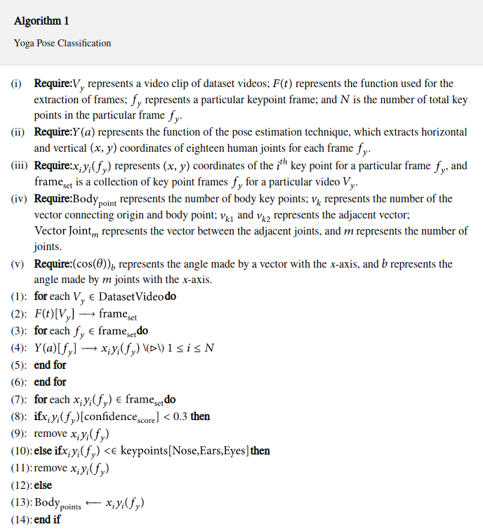

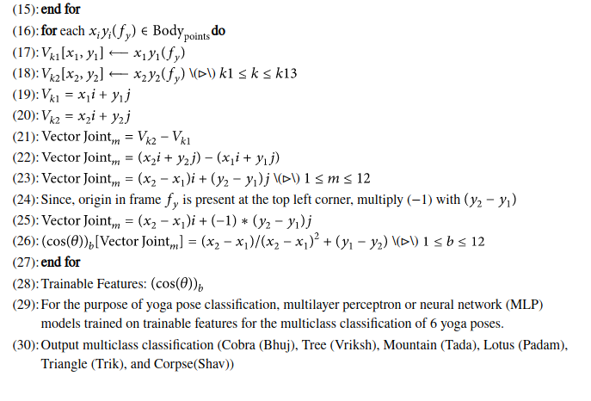

The proposed approach is represented schematically in Figure [2](https://www.hindawi.com/journals/cin/2022/4311350/fig2/), and further explanations of each step are provided in the following sections.

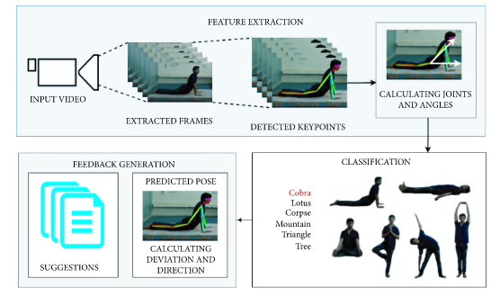

**Figure 2**

A schematic diagram of the proposed approach for correct yoga pose estimation and feedback generations for incorrect posture.

##### **Datasets**

The proposed methodology is examined on a publicly available, online, open-source collection [30] dataset. This dataset includes 4 yoga poses, namely, Lotus (Padam), Mountain (Tada), Chair(Utkatasana), Tree(Vrikshasana). Total videos of the 4 poses are 47, and total instances combining the 4 poses are 350. These videos are recorded in a room using the camera from a distance of 4 meters; the frame per second rate is 30. To have robust trained models, individuals performed these poses with few variations. Table [1](https://www.hindawi.com/journals/cin/2022/4311350/tab1/) summarizes the statistics of the dataset in terms of video count, duration of each activity class in seconds, and the number of persons for each yoga pose separately, and some sample frames of every pose are depicted in Figure [3](https://www.hindawi.com/journals/cin/2022/4311350/fig3/).

|  |  |  |  |  |  |  |  |  |  |  |  |  |  |  |  |  |  |  |  |  |  |  |  |  |  |  |  |  |  |  |  |  |  |  |  |  |  |  |  |  |
| --- | --- | --- | --- | --- | --- | --- | --- | --- | --- | --- | --- | --- | --- | --- | --- | --- | --- | --- | --- | --- | --- | --- | --- | --- | --- | --- | --- | --- | --- | --- | --- | --- | --- | --- | --- | --- | --- | --- | --- | --- |
| Table 1  Summarization of statistics of the dataset of each yoga pose.   |  |  |  |  | | --- | --- | --- | --- | |  | | | | | Yoga pose | Time (s) | Persons | Videos | |  | | | | |  |  |  |  | |  |  |  |  | | Lotus pose | 495 | 15 | 10 | | Mountain pose | 585 | 15 | 12 | | Chair pose | 615 | 15 | 14 | | Tree pose | 500 | 15 | 11 | | Total |  |  | 47 |      1. (b) |

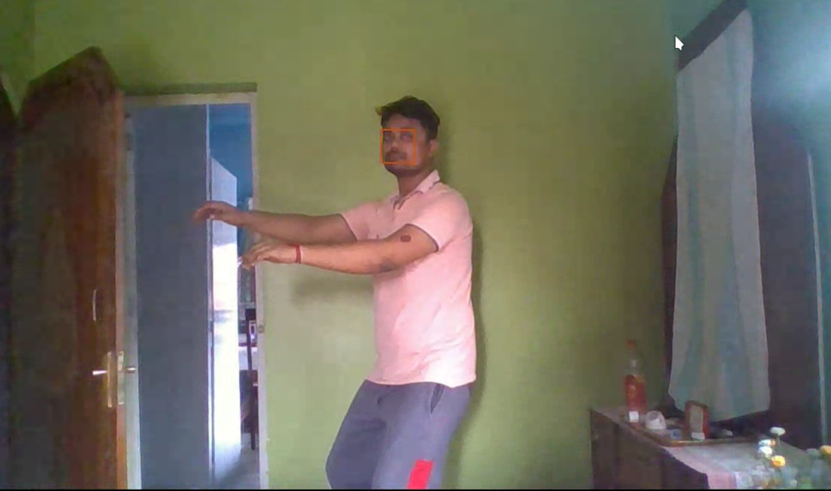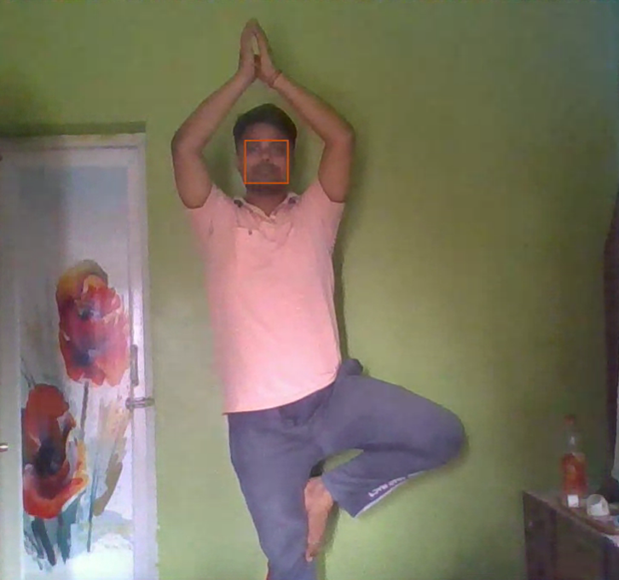

(c) (d)

Sample frames for each yoga pose : (a) Lotus pose, (b) Mountain pose, (c) Chair pose, (d) Tree pose

This dataset is used for training (320 instances) and validation (30 instances). A separate dataset is created from these videos at different time intervals for testing. This separate dataset contains a total of 30 instances, 5 for each pose.

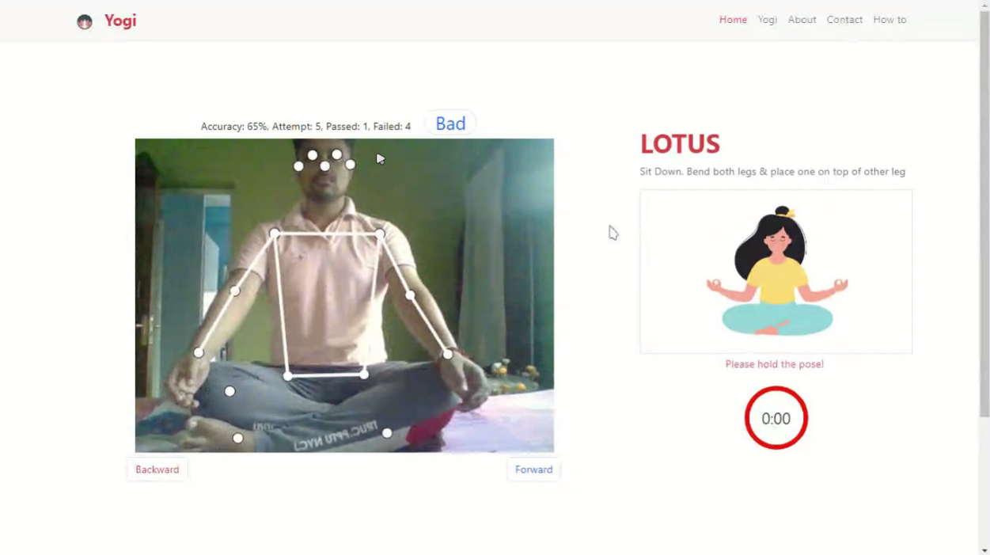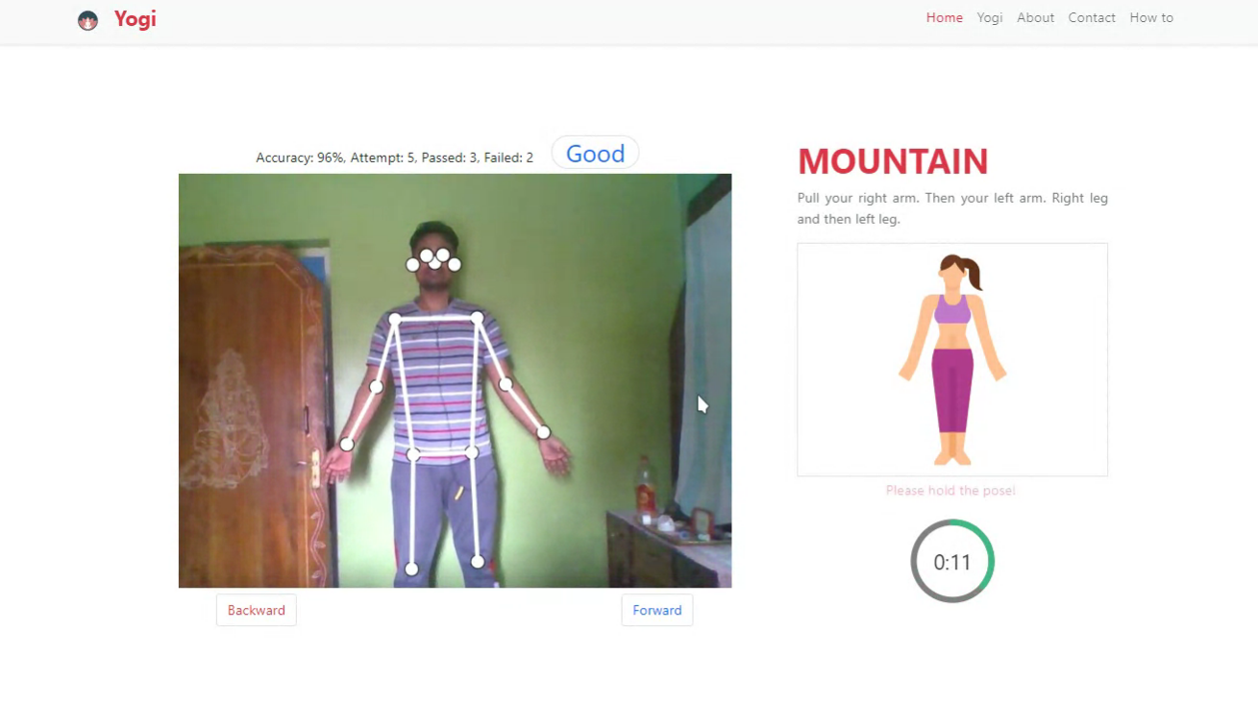

1. (b)

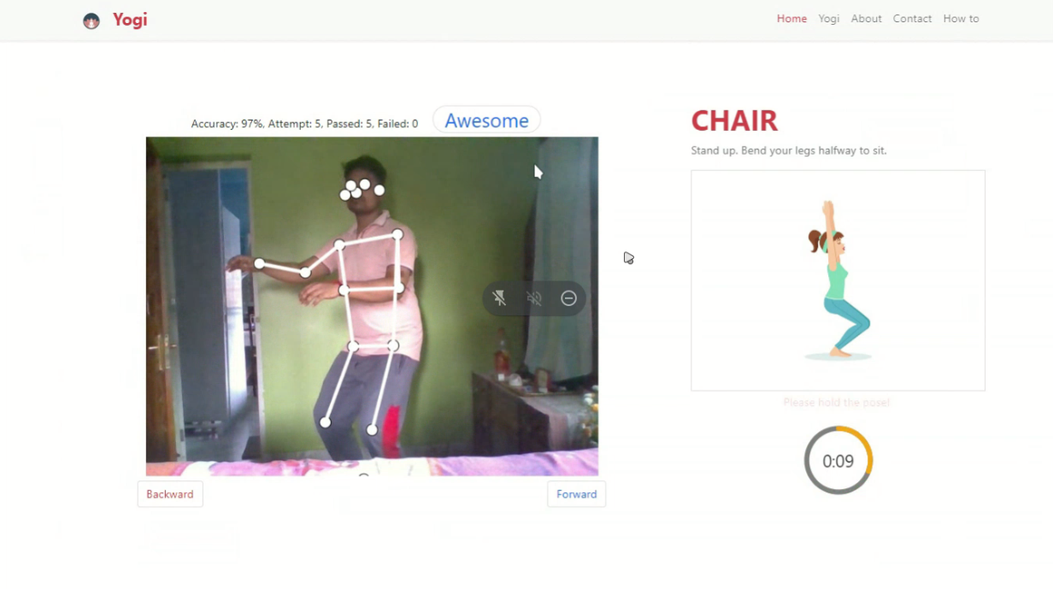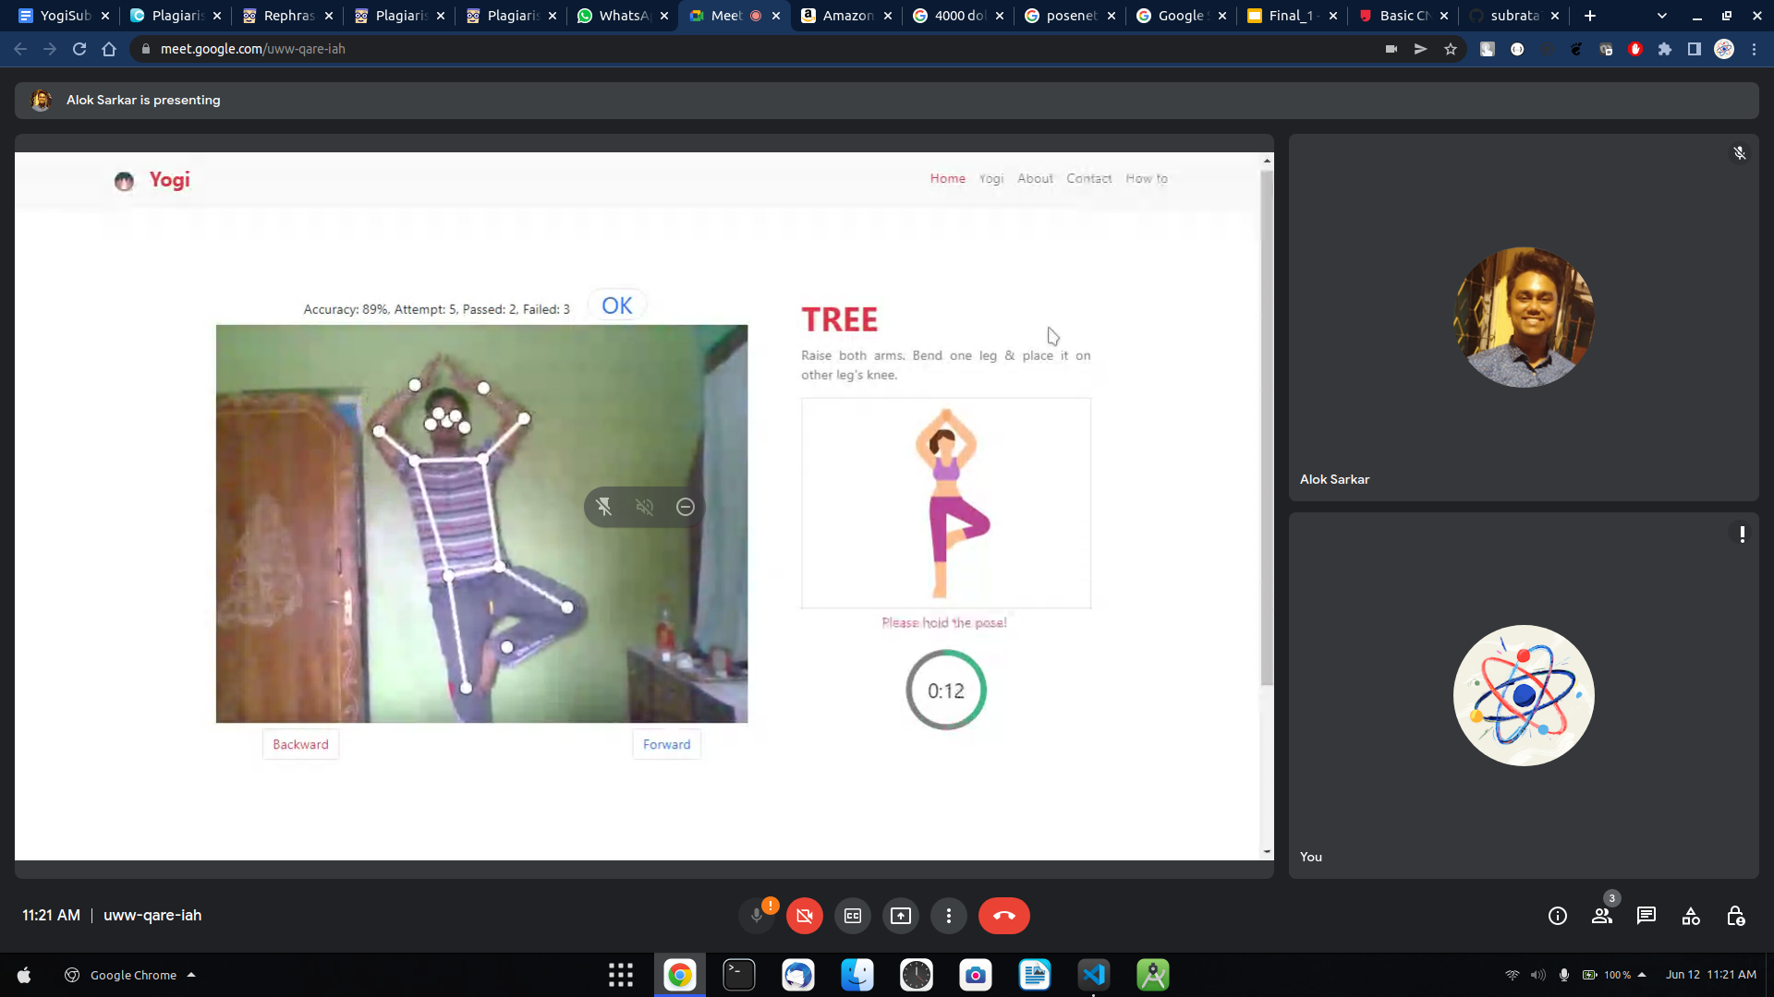

(c) (d)

Demonstration of key points extraction on all 4 yoga poses: (a) Lotus pose, (b) Mountain pose, (c) Chair pose, (d) Tree pose

##### **Feature Extraction**

To extract key points for pose estimation, Keras real-time multi person pose estimation is utilized [7, 8]. This pose estimation is run on every video, frames are extracted for every 2 seconds, and pose is calculated for 5 consecutive frames of each video, which results in 350 instances for 47 videos. Every pose outputs an array of 18 key points where every point consists of *x* and *y* coordinates. Figure [5](https://www.hindawi.com/journals/cin/2022/4311350/fig5/) shows key points extracted from a frame by the pose estimation code.

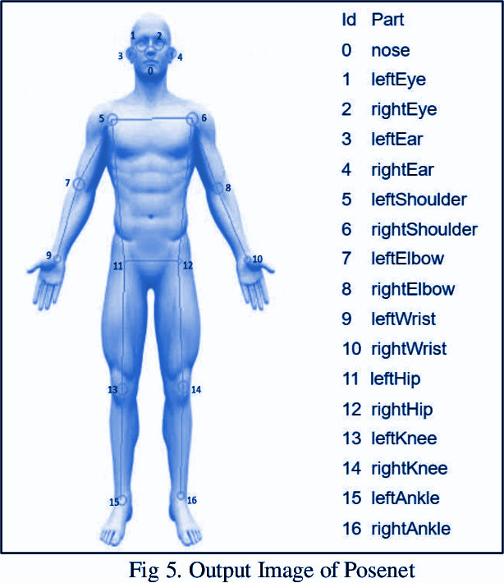

The research work has used 320 instances for training. While detecting poses for a person, many key points are being detected with different confidence levels. Keras pose estimation works in such a way where it includes the first key point detected without taking into consideration confidence intervals. In this paper, a few modifications were done to the Keras pose estimation to consider key points of highest confidence levels. With these *x* and *y* coordinates, the study extracted features like angles between body joints and with the ground so that models will be trained to achieve good accuracy. Utmost priority is given to these instances so that there will be no abnormality data given as input. Figure [6](https://www.hindawi.com/journals/cin/2022/4311350/fig6/) depicts pose estimation on all 4 yoga poses.

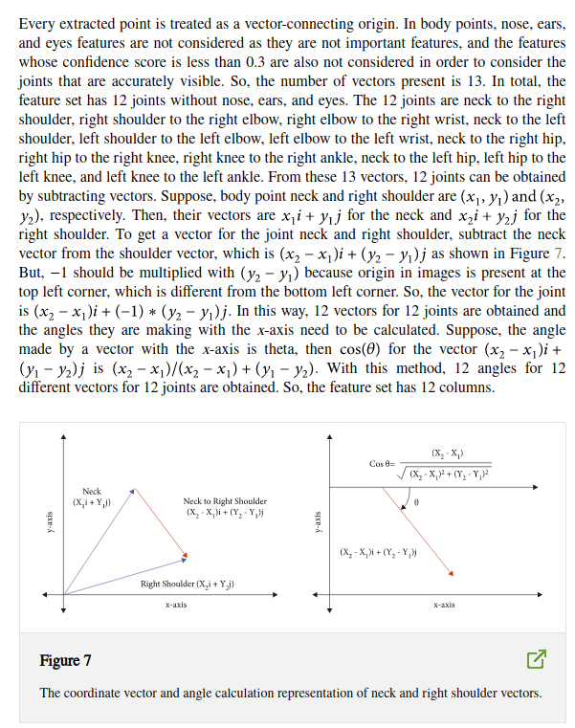

These angles extracted are scaled and rotation variants. Different poses varying in distances from the camera need to scale key points to train models to achieve high accuracy. But, when angles are used as features, varying distances does not have any need to scale any feature. For example, if the joint left ankle and left knee make 90 with the ground, considering for different distances from the camera, the angle made by this joint will be the same at any distance. If points are rotated, suppose the joint left ankle and left knee rotate by any slight angle, then the angle made by the *x*-axis will be varied. In reference [29], angles made at the hip will not change if all 3 key points (shoulders, hips, and knees) rotate at the same angle. In reference [28], if two key points are swapped, then the angle made concerning the reference point will not change. Hence, angles used in references [28, 29] are rotation invariant, and in the system, angles are rotation variants.

##### **Feedback Generation**

In the dataset, average values or angles are calculated for every pose by considering all poses done by everyone. When images are given as input to the model, the trained model classifies the pose with which it aligns. The angles extracted from the image are compared with the average values calculated. The differences between these angles are calculated, respectively, that is, 12 values are calculated. To give suggestions, two parameters are needed—how much the pose is deviated from the original and in what direction. The magnitude of these 12 difference values tells by how much one must correct his pose, and for the direction, the researchers used the sign whether it is positive or negative, which tells us to rotate the joints in either clockwise or anticlockwise direction. With this method, suggestions are given to users for every joint.

#### **Results**

We can observe a detailed description and a brief summary of our Sequential model. We started with 32 filters, 3 by 3 kernel size that is our convolution window size, activation function as relu that filters all non-positive numbers, padding evenly with input and 3-dimensional input shape. Similarly, we have taken 64 filters in the 2nd layer. (No of parameters = out channels * (in-channels*kernel_height*kernel_width+1)). In the polling layer we used max pooling that gets maximum value from the convolution window and mapping it to a 2 by 2 window for extracting sharp and smooth features. After that dropout regulation helps to cut out the part of input to collect zero that prevents the model from over fitting. After that, collecting feature maps in the dense layer and using softmax for multi-class classification.

We compile the model with catagorical_crossintropy loss function, adam as an optimizer and accuracy matrix for better results.

There we can see the result of model fitting, inputting training data , stps_per_epoch, epochs, validationg_data, validation steps. We increase training accuracy, decreasing training loss. Hence our predicted results for each class.

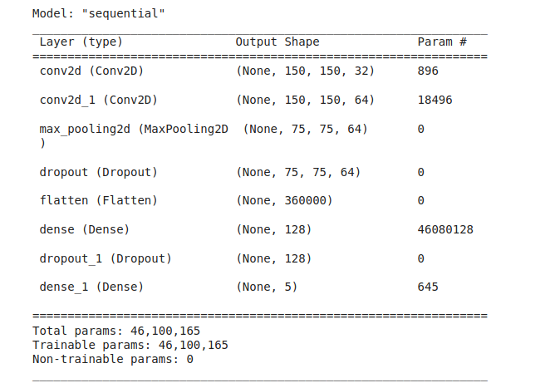

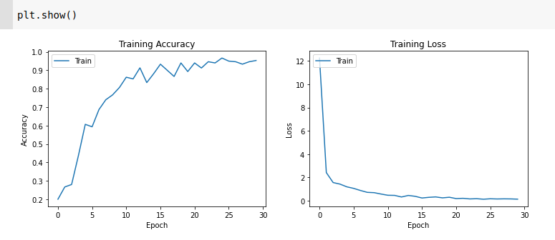

Both training and validation datasets have many ups and downs in accuracy till the 20 epoch and attained an accuracy of 0.9958 at the 20 epoch. From 20 to 30 epochs, loss of training and validation decreased gradually, which resulted in the training model classifying with high confidence. From epoch 0 to 30, the loss of validation and training datasets decreased gradually. From the training and validation accuracy obtained, it can be inferred that the model is not overfitting. The loss function used is categorical cross-entropy since the research is classifying input features into one of the 6 labels. An AdaDelta optimizer is used based on the adaptive learning rate to address two drawbacks: (1) decay of learning rates and (2) selection of the global learning rate. The activation function used for the last layer is softmax since it outputs confidence levels for all labels. The one with the highest confidence is the predicted label.

Table [2](https://www.hindawi.com/journals/cin/2022/4311350/tab2/) represents the accuracy result of the experimented models, SVM obtained accuracy results of 0.9319, CNN obtained accuracy results of 0.9858, and CNN + LSTM achieved accuracy results of 0.9938.

|  |  |  |  |  |  |  |  |  |  |  |  |  |  |  |  |  |  |  |  |  |  |  |  |  |  |  |
| --- | --- | --- | --- | --- | --- | --- | --- | --- | --- | --- | --- | --- | --- | --- | --- | --- | --- | --- | --- | --- | --- | --- | --- | --- | --- | --- |
| Table represents the accuracy result of the experimented models.   |  |  |  | | --- | --- | --- | |  | | | | Model | Accuracy | | | Training | Testing | |  | | | | SVM | 0.9532 | 0.9319 | | CNN | 0.9934 | 0.9858 | | CNN + LSTM | 0.9987 | 0.9938 | |  |  |  | |  | | | |

To examine the effectiveness of the proposed methodology, a confusion matrix is utilized that describes the classification model performance for all instances in terms of accuracy as per equation ([1](https://www.hindawi.com/journals/cin/2022/4311350/#EEq1)). Classification accuracy is also known as classification score, which is the ratio of correct classifications and total instances.

The confusion matrix used in the study has 6 labels, so the result evaluation has a confusion matrix. The row represents the actual class, while the column represents the predicted class of the proposed data. Figure [10](https://www.hindawi.com/journals/cin/2022/4311350/fig10/) depicts the confusion matrices of training, validation, and testing datasets. In the confusion matrix of the training, validation, and training dataset, the total number of instances are 320, 30, and 30, respectively. It can observe that all the samples are predicted correctly, which results in an accuracy of 0.9958 for all cases. Figure [11](https://www.hindawi.com/journals/cin/2022/4311350/fig11/) represents the plot for different competitive models.

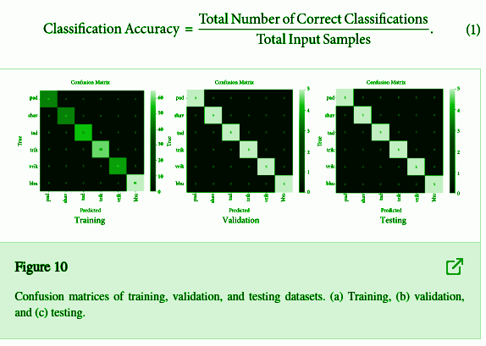

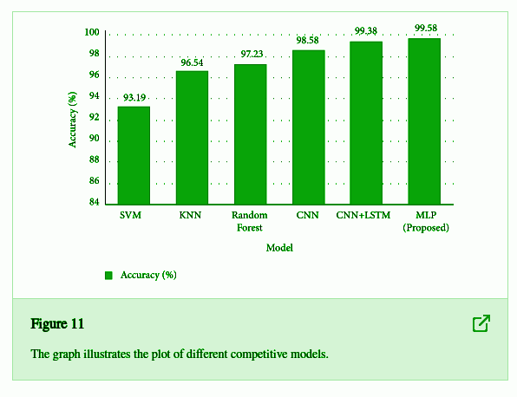

#### 

**Implementation and real-time user experience of our web app**



Exploring the web app

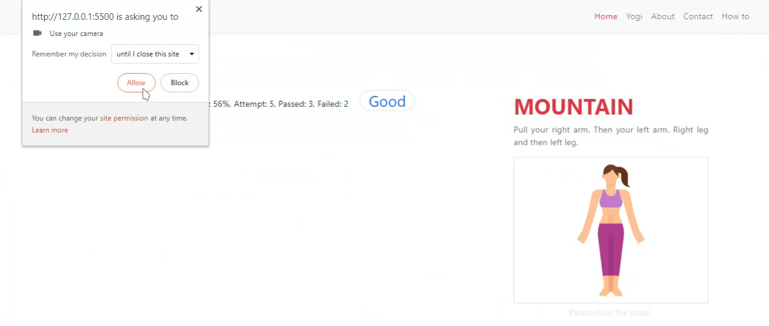

Granting camera permission



Mountain pose detection (Accuracy : 96%, Attempt: 5, Passed: 3, Failed: 2, Feedback : Good)



Lotus pose detection (Accuracy : 65%, Attempt: 5, Passed: 1, Failed: 4, Feedback : Bad)

Chair pose detection (Accuracy : 97%, Attempt: 5, Passed: 5, Failed: 0, Feedback : Awesome)



Tree pose detection (Accuracy : 89%, Attempt: 5, Passed: 2, Failed: 3, Feedback : OK)

#### **5. Runtime Analysis**

The approaches presented in this research are based on deep learning to detect incorrect yoga posture and also advise the user to improve the posture. In this research, extraction of key points using a pose estimation technique, computation of vectors for each joint, and the angle between the vectors for adjacent joints are categorized as features. Following that, these features were fed into the classification techniques, and later, the feedback for the correctness of the yoga pose was generated. Therefore, the runtime is divided into three parts: (1) extraction and computation of features time for every frame, (2) classification, and (3) feedback generation time of categorizing yoga pose per frame. The runtime for the extraction and computation of features remains constant for each method. The runtime analysis is carried out on Intel I3 and NVIDIA GeForce GTX 650.

Table [3](https://www.hindawi.com/journals/cin/2022/4311350/tab3/) presents the mean average runtime per frame together with the standard deviation of the experimental methodology. The time is presented in milliseconds. It incorporates the time taken per frame on feature extraction and classification with feedback development.

|  |  |  |  |  |
| --- | --- | --- | --- | --- |
|  | | | | |
| Methods | CPU | | GTX-650 | |
| Mean (F.E.+C) | Mean (F.G.) | Mean (F.E.+C) | Mean (F.G.) |
|  | | | | |
| SVM | 6574.8 134.7 | 16.4 | 214.5 10.6 | 10.32 |
| CNN | 6528.6 112.6 | 15.2 | 208.4 15.2 | 8.36 |
| CNN + LSTM | 6512.6 118.4 | 16.6 | 206.8 16.8 | 7.18 |
|  |  |  |  |  |
|  |  |  |  |  |

#### 

#### **6. Conclusions**

The approaches presented in this research are based on deep learning to detect incorrect yoga posture and also advise the user to improve the pose by specifying where the yoga pose is going wrong. In the proposed system, the users can select the desired pose for practice and can upload recorded videos of their yoga practice pose. The research has extracted monitoring activities angles and used them as a feature as they are scaled. In some cases, if key points are rotated then angles are not changing, which does not deliver good results. In this system, angles with the ground are considered but not between joints, so if there is any slight rotation of key points, then angles are changed. With these features, CNNs are trained to achieve an accuracy of 0.9958 for testing datasets. In existing research, SVM achieved a test accuracy of 0.9319, CNN achieved 0.9858, and CNN + LSTM achieved 0.9938. In the system, CNN power is much lower than CNN + LSTM but achieved an accuracy of 0.9958 with modified features. When compared to existing techniques, the experimental results show promising results. The proposed approach maintains low computational complexity, can be applied to someone’s busy life for self-yoga learning, and can detect incorrect yoga posture to avoid chronic problems.

##### **7. Future Scope**

The proposed system is confined to 4 yoga poses, where there are a total of more than 80 yoga poses. The proposed dataset can be expanded by adding required yoga pose key points. The technology may also be used to make real-time predictions and self-training on a mobile device. There are several instances of real-life applications in which a single individual posture evaluation will not be enough; for example, a pose estimate in crowded environments will need to detect and recognize the pose of each participant. To include many poses and to get model works on many poses (classifying many poses) is challenging enough. Keras pose estimation influences the performance of the model; steps should be taken to get key points when body parts are overlapped or missing to achieve better results. This method to extract angles as features can be used for other applications like activity detection and sports activity monitoring.

#### **References**

1. S. Patil, A. Pawar, A. Peshave, A. N. Ansari, and A. Navada, “Yoga tutor visualization and analysis using SURF algorithm,” in *Proceedings of the 2011 IEEE Control and System Graduate Research Colloquium*, pp. 43–46, IEEE, Shah Alam, Malaysia, June 2011.
2. View at: [Google Scholar](https://scholar.google.com/scholar_lookup?title=Yoga%20tutor%20visualization%20and%20analysis%20using%20SURF%20algorithm&author=S.%20Patil&author=A.%20Pawar&author=A.%20Peshave&author=A.%20N.%20Ansari&author=&author=A.%20Navada)
3. W. Wu, W. Yin, and F. Guo, “Learning and self-instruction expert system for Yoga,” in *Proceedings of the 2010 2nd International Workshop on Intelligent Systems and Applications*, pp. 1–4, IEEE, Mumbai, India, May 2010.
4. View at: [Google Scholar](https://scholar.google.com/scholar_lookup?title=Learning%20and%20self-instruction%20expert%20system%20for%20Yoga&author=W.%20Wu&author=W.%20Yin&author=&author=F.%20Guo)
5. H. T. Chen, Y. Z. He, C. L. Chou, S. Y. Lee, B. S. P. Lin, and J. Y. Yu, “Computer-assisted self-training system for sports exercise using kinects,” in *Proceedings of the 2013 IEEE International Conference on Multimedia and Expo Workshops (ICMEW)*, pp. 1–4, IEEE, London, UK, July 2013.
6. View at: [Google Scholar](https://scholar.google.com/scholar_lookup?title=Computer-assisted%20self-training%20system%20for%20sports%20exercise%20using%20kinects&author=H.%20T.%20Chen&author=Y.%20Z.%20He&author=C.%20L.%20Chou&author=S.%20Y.%20Lee&author=B.%20S.%20P.%20Lin&author=&author=J.%20Y.%20Yu)
7. E. W. Trejo and P. Yuan, “Recognition of Yoga poses through an interactive system with Kinect device,” in *Proceedings of the 2018 2nd International Conference on Robotics and Automation Sciences (ICRAS)*, pp. 1–5, IEEE, Wuhan, China, June 2018.
8. View at: [Google Scholar](https://scholar.google.com/scholar_lookup?title=Recognition%20of%20Yoga%20poses%20through%20an%20interactive%20system%20with%20Kinect%20device&author=E.%20W.%20Trejo%20&author=P.%20Yuan)
9. A. Mohanty, A. Ahmed, T. Goswami, A. Das, P. Vaishnavi, and R. R. Sahay, “Robust pose recognition using deep learning,” in *Proceedings of the International Conference on Computer Vision and Image Processing*, pp. 93–105, Springer, Singapore, December 2017.
10. View at: [Google Scholar](https://scholar.google.com/scholar_lookup?title=Robust%20pose%20recognition%20using%20deep%20learning&author=A.%20Mohanty&author=A.%20Ahmed&author=T.%20Goswami&author=A.%20Das&author=P.%20Vaishnavi&author=&author=R.%20R.%20Sahay)
11. A. Toshev and C. Szegedy, “Deeppose: human pose estimation via deep neural networks,” in *Proceedings of the IEEE conference on computer vision and pattern recognition*, pp. 1653–1660, Columbus, OH, USA, August 2014.
12. View at: [Google Scholar](https://scholar.google.com/scholar_lookup?title=Deeppose:%20human%20pose%20estimation%20via%20deep%20neural%20networks&author=A.%20Toshev%20&author=C.%20Szegedy)
13. Z. Cao, T. Simon, S. E. Wei, and Y. Sheikh, “Realtime multi-person 2d pose estimation using part affinity fields,” in *Proceedings of the IEEE conference on computer vision and pattern recognition*, pp. 7291–7299, Honolulu, HW, USA, July 2017.
14. View at: [Google Scholar](https://scholar.google.com/scholar_lookup?title=Realtime%20multi-person%202d%20pose%20estimation%20using%20part%20affinity%20fields&author=Z.%20Cao&author=T.%20Simon&author=S.%20E.%20Wei&author=&author=Y.%20Sheikh)
15. Z. Cao, G. Hidalgo, T. Simon, S. E. Wei, and Y. Sheikh, “OpenPose: realtime multi-person 2D pose estimation using Part Affinity Fields,” *IEEE Transactions on Pattern Analysis and Machine Intelligence*, vol. 43, no. 1, pp. 172–186, 2019.
16. View at: [Google Scholar](https://scholar.google.com/scholar_lookup?title=OpenPose:%20realtime%20multi-person%202D%20pose%20estimation%20using%20Part%20Affinity%20Fields&author=Z.%20Cao&author=G.%20Hidalgo&author=T.%20Simon&author=S.%20E.%20Wei&author=&author=Y.%20Sheikh&publication_year=2019)
17. A. Kendall, M. Grimes, and R. Cipolla, “Posenet: a convolutional network for real-time 6-dof camera relocalization,” in *Proceedings of the IEEE international conference on computer vision*, pp. 2938–2946, Santiago, Chile, December 2015.
18. View at: [Google Scholar](https://scholar.google.com/scholar_lookup?title=Posenet:%20a%20convolutional%20network%20for%20real-time%206-dof%20camera%20relocalization&author=A.%20Kendall&author=M.%20Grimes&author=&author=R.%20Cipolla)
19. S. Kreiss, L. Bertoni, and A. Alahi, “Pifpaf: composite fields for human pose estimation,” in *Proceedings of the IEEE/CVF Conference on Computer Vision and Pattern Recognition*, pp. 11977–11986, Long Beach, CA, USA, June 2019.
20. View at: [Google Scholar](https://scholar.google.com/scholar_lookup?title=Pifpaf:%20composite%20fields%20for%20human%20pose%20estimation&author=S.%20Kreiss&author=L.%20Bertoni&author=&author=A.%20Alahi)
21. W. Gong, X. Zhang, J. Gonzàlez et al., “Human pose estimation from monocular images: a comprehensive survey,” *Sensors*, vol. 16, no. 12, p. 1966, 2016.
22. View at: [Publisher Site](https://doi.org/10.3390/s16121966) | [Google Scholar](https://scholar.google.com/scholar_lookup?title=Human%20pose%20estimation%20from%20monocular%20images:%20a%20comprehensive%20survey&author=W.%20Gong&author=X.%20Zhang&author=J.%20Gonz%C3%A0lez%20et%20al.&publication_year=2016)
23. K. Pothanaicker, “Human action recognition using CNN and LSTM-RNN with attention model,” *Intl Journal of Innovative Tech. and Exploring Eng*, vol. 8, no. 8, 2019.
24. View at: [Google Scholar](https://scholar.google.com/scholar_lookup?title=Human%20action%20recognition%20using%20CNN%20and%20LSTM-RNN%20with%20attention%20model&author=K.%20Pothanaicker&publication_year=2019)
25. R. A. Güler, N. Neverova, and I. Kokkinos, “Densepose: dense human pose estimation in the wild,” in *Proceedings of the IEEE Conference on Computer Vision and Pattern Recognition*, pp. 7297–7306, Salt Lake City, UT, USA, June 2018.
26. View at: [Google Scholar](https://scholar.google.com/scholar_lookup?title=Densepose:%20dense%20human%20pose%20estimation%20in%20the%20wild&author=R.%20A.%20G%C3%BCler&author=N.%20Neverova&author=&author=I.%20Kokkinos)
27. H.-T. Chen, Y.-Z. He, and C.-C. Hsu, “Computer-assisted yoga training system,” *Multimedia Tools and Applications*, vol. 77, no. 18, pp. 23969–23991, 2018.
28. View at: [Publisher Site](https://doi.org/10.1007/s11042-018-5721-2) | [Google Scholar](https://scholar.google.com/scholar_lookup?title=Computer-assisted%20yoga%20training%20system&author=H.-T.%20Chen&author=Y.-Z.%20He&author=&author=C.-C.%20Hsu&publication_year=2018)
29. S. Jain, A. Rustagi, S. Saurav, R. Saini, and S. Singh, “Three-dimensional CNN-inspired deep learning architecture for Yoga pose recognition in the real-world environment,” *Neural Computing & Applications*, vol. 33, no. 12, pp. 6427–6441, 2021.
30. View at: [Publisher Site](https://doi.org/10.1007/s00521-020-05405-5) | [Google Scholar](https://scholar.google.com/scholar_lookup?title=Three-dimensional%20CNN-inspired%20deep%20learning%20architecture%20for%20Yoga%20pose%20recognition%20in%20the%20real-world%20environment&author=S.%20Jain&author=A.%20Rustagi&author=S.%20Saurav&author=R.%20Saini&author=&author=S.%20Singh&publication_year=2021)
31. C. C. Hsieh, B. S. Wu, and C. C. Lee, “A distance computer vision assisted yoga learning system,” *Journal of Computers*, vol. 6, no. 11, pp. 2382–2388, 2011.
32. View at: [Google Scholar](https://scholar.google.com/scholar_lookup?title=A%20distance%20computer%20vision%20assisted%20yoga%20learning%20system&author=C.%20C.%20Hsieh&author=B.%20S.%20Wu&author=&author=C.%20C.%20Lee&publication_year=2011)
33. M. T. Uddin and M. A. Uddiny, “Human activity recognition from wearable sensors using extremely randomized trees,” in *Proceedings of the 2015 International Conference on Electrical Engineering and Information Communication Technology (ICEEICT)*, pp. 1–6, IEEE, London, UK, 2015 May.
34. View at: [Google Scholar](https://scholar.google.com/scholar_lookup?title=Human%20activity%20recognition%20from%20wearable%20sensors%20using%20extremely%20randomized%20trees&author=M.%20T.%20Uddin%20&author=M.%20A.%20Uddiny)
35. A. Jalal, N. Sarif, J. T. Kim, and T.-S. Kim, “Human activity recognition via recognized body parts of human depth silhouettes for residents monitoring services at smart home,” *Indoor and Built Environment*, vol. 22, no. 1, pp. 271–279, 2013.
36. View at: [Publisher Site](https://doi.org/10.1177/1420326x12469714) | [Google Scholar](https://scholar.google.com/scholar_lookup?title=Human%20activity%20recognition%20via%20recognized%20body%20parts%20of%20human%20depth%20silhouettes%20for%20residents%20monitoring%20services%20at%20smart%20home&author=A.%20Jalal&author=N.%20Sarif&author=J.%20T.%20Kim&author=&author=T.-S.%20Kim&publication_year=2013)
37. Y. Zhan and T. Kuroda, “Wearable sensor-based human activity recognition from environmental background sounds,” *Journal of Ambient Intelligence and Humanized Computing*, vol. 5, no. 1, pp. 77–89, 2014.
38. View at: [Publisher Site](https://doi.org/10.1007/s12652-012-0122-2) | [Google Scholar](https://scholar.google.com/scholar_lookup?title=Wearable%20sensor-based%20human%20activity%20recognition%20from%20environmental%20background%20sounds&author=Y.%20Zhan%20&author=T.%20Kuroda&publication_year=2014)
39. P.-F. Pai, L.-H. ChangLiao, and K.-P. Lin, “Analyzing basketball games by a support vector machines with decision tree model,” *Neural Computing & Applications*, vol. 28, no. 12, pp. 4159–4167, 2017.
40. View at: [Publisher Site](https://doi.org/10.1007/s00521-016-2321-9) | [Google Scholar](https://scholar.google.com/scholar_lookup?title=Analyzing%20basketball%20games%20by%20a%20support%20vector%20machines%20with%20decision%20tree%20model&author=P.-F.%20Pai&author=L.-H.%20ChangLiao&author=&author=K.-P.%20Lin&publication_year=2017)
41. S. Haque, A. S. A. Rabby, M. A. Laboni, N. Neehal, and S. A. Hossain, “ExNET: deep neural network for exercise pose detection,” in *Proceedings of the International Conference on Recent Trends in Image Processing and Pattern Recognition*, pp. 186–193, Springer, Singapore, December 2018.
42. View at: [Google Scholar](https://scholar.google.com/scholar_lookup?title=ExNET:%20deep%20neural%20network%20for%20exercise%20pose%20detection&author=S.%20Haque&author=A.%20S.%20A.%20Rabby&author=M.%20A.%20Laboni&author=N.%20Neehal&author=&author=S.%20A.%20Hossain)
43. J. Palanimeera and K. Ponmozhi, “Classification of yoga pose using machine learning techniques,” *Materials Today Proceedings*, vol. 37, pp. 2930–2933, 2021.
44. View at: [Publisher Site](https://doi.org/10.1016/j.matpr.2020.08.700) | [Google Scholar](https://scholar.google.com/scholar_lookup?title=Classification%20of%20yoga%20pose%20using%20machine%20learning%20techniques&author=J.%20Palanimeera%20&author=K.%20Ponmozhi&publication_year=2021)
45. L. Casas, N. Navab, and S. Demirci, “Patient 3D body pose estimation from pressure imaging,” *International Journal of Computer Assisted Radiology and Surgery*, vol. 14, no. 3, pp. 517–524, 2019.
46. View at: [Google Scholar](https://scholar.google.com/scholar_lookup?title=Patient%203D%20body%20pose%20estimation%20from%20pressure%20imaging&author=L.%20Casas&author=N.%20Navab&author=&author=S.%20Demirci&publication_year=2019)
47. Y. Shavit and R. Ferens, “Introduction to camera pose estimation with deep learning.,” 2019, <https://arxiv.org/abs/1907.05272>.
48. View at: [Google Scholar](https://scholar.google.com/scholar_lookup?title=Introduction%20to%20camera%20pose%20estimation%20with%20deep%20learning.&author=Y.%20Shavit%20&author=R.%20Ferens&publication_year=2019)
49. N. D. Thang, T.-S. Kim, Y.-K. Lee, and S. Lee, “Estimation of 3-D human body posture via co-registration of 3-D human model and sequential stereo information,” *Applied Intelligence*, vol. 35, no. 2, pp. 163–177, 2011.
50. View at: [Publisher Site](https://doi.org/10.1007/s10489-009-0209-4) | [Google Scholar](https://scholar.google.com/scholar_lookup?title=Estimation%20of%203-D%20human%20body%20posture%20via%20co-registration%20of%203-D%20human%20model%20and%20sequential%20stereo%20information&author=N.%20D.%20Thang&author=T.-S.%20Kim&author=Y.-K.%20Lee&author=&author=S.%20Lee&publication_year=2011)
51. M. Z. Uddin, N. D. Thang, and T. S. Kim, “Human activity recognition via 3-D joint angle features and hidden Markov models,” in *Proceedings of the 2010 IEEE International Conference on Image Processing*, pp. 713–716, IEEE, Hong Kong, China, 2010 September.
52. View at: [Google Scholar](https://scholar.google.com/scholar_lookup?title=Human%20activity%20recognition%20via%203-D%20joint%20angle%20features%20and%20hidden%20Markov%20models&author=M.%20Z.%20Uddin&author=N.%20D.%20Thang&author=&author=T.%20S.%20Kim)
53. F. Ofli, R. Chaudhry, G. Kurillo, R. Vidal, and R. Bajcsy, “Sequence of the most informative joints (smij): a new representation for human skeletal action recognition,” *Journal of Visual Communication and Image Representation*, vol. 25, no. 1, pp. 24–38, 2014.
54. View at: [Publisher Site](https://doi.org/10.1016/j.jvcir.2013.04.007) | [Google Scholar](https://scholar.google.com/scholar_lookup?title=Sequence%20of%20the%20most%20informative%20joints%20(smij):%20a%20new%20representation%20for%20human%20skeletal%20action%20recognition&author=F.%20Ofli&author=R.%20Chaudhry&author=G.%20Kurillo&author=R.%20Vidal&author=&author=R.%20Bajcsy&publication_year=2014)
55. Ö.F İnce, I. F. Ince, M. E. Yıldırım, J. S. Park, J. K. Song, and B. W. Yoon, “Human activity recognition with analysis of angles between skeletal joints using a RGB-depth sensor,” *ETRI Journal*, vol. 42, no. 1, pp. 78–89, 2020.
56. View at: [Google Scholar](https://scholar.google.com/scholar_lookup?title=Human%20activity%20recognition%20with%20analysis%20of%20angles%20between%20skeletal%20joints%20using%20a%20RGB-depth%20sensor&author=%C3%96.F%20%C4%B0nce&author=I.%20F.%20Ince&author=M.%20E.%20Y%C4%B1ld%C4%B1r%C4%B1m&author=J.%20S.%20Park&author=J.%20K.%20Song&author=&author=B.%20W.%20Yoon&publication_year=2020)
57. A. Guler, N. Kardaris, S. Chandra et al., “Human joint angle estimation and gesture recognition for assistive robotic vision,” in *Proceedings of the European Conference on Computer Vision*, pp. 415–431, Springer, Amsterdam, The Netherlands, October 2016.
58. View at: [Google Scholar](https://scholar.google.com/scholar_lookup?title=Human%20joint%20angle%20estimation%20and%20gesture%20recognition%20for%20assistive%20robotic%20vision&author=A.%20Guler&author=N.%20Kardaris&author=S.%20Chandra%20et%20al.)
59. S. K. Yadav, A. Singh, A. Gupta, and J. L. Raheja, “Real-time Yoga recognition using deep learning,” *Neural Computing & Applications*, vol. 31, no. 12, pp. 9349–9361, 2019.
60. View at: [Publisher Site](https://doi.org/10.1007/s00521-019-04232-7) | [Google Scholar](https://scholar.google.com/scholar_lookup?title=Real-time%20Yoga%20recognition%20using%20deep%20learning&author=S.%20K.%20Yadav&author=A.%20Singh&author=A.%20Gupta&author=&author=J.%20L.%20Raheja&publication_year=2019)
61. P. Szczuko, “Deep neural networks for human pose estimation from a very low resolution depth image,” *Multimedia Tools and Applications*, vol. 78, no. 20, pp. 29357–29377, 2019.
62. View at: [Publisher Site](https://doi.org/10.1007/s11042-019-7433-7) | [Google Scholar](https://scholar.google.com/scholar_lookup?title=Deep%20neural%20networks%20for%20human%20pose%20estimation%20from%20a%20very%20low%20resolution%20depth%20image&author=P.%20Szczuko&publication_year=2019)